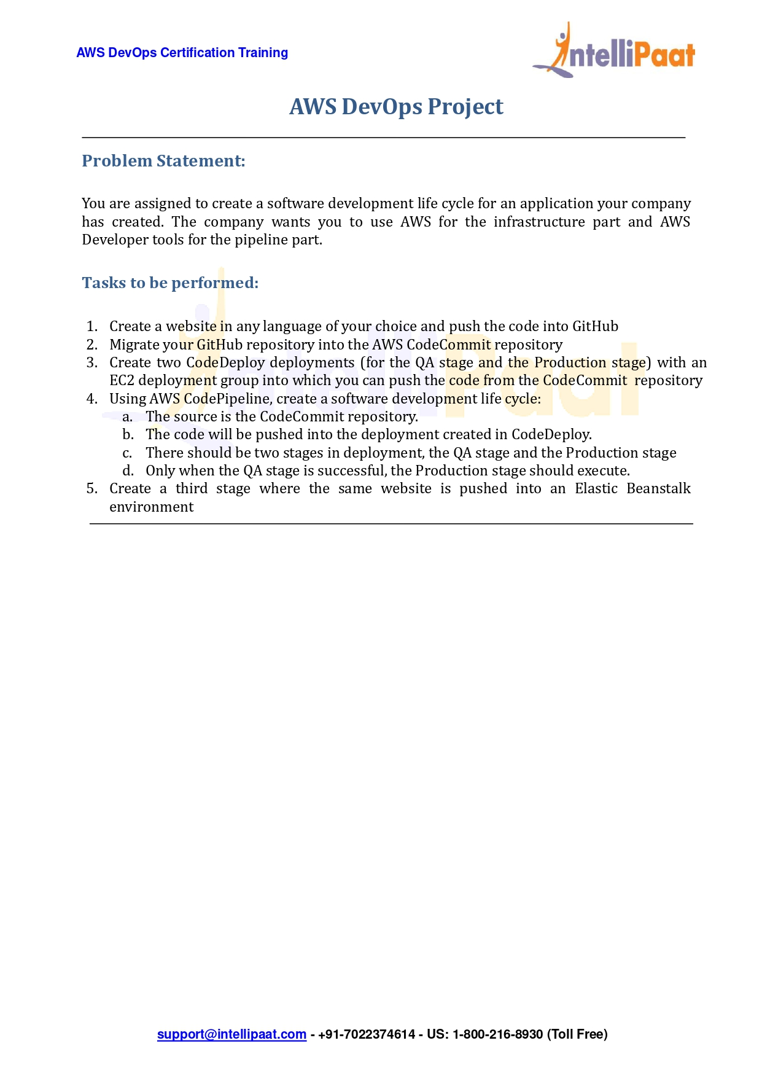

Name: samata salunke

Project: AWS DevOps

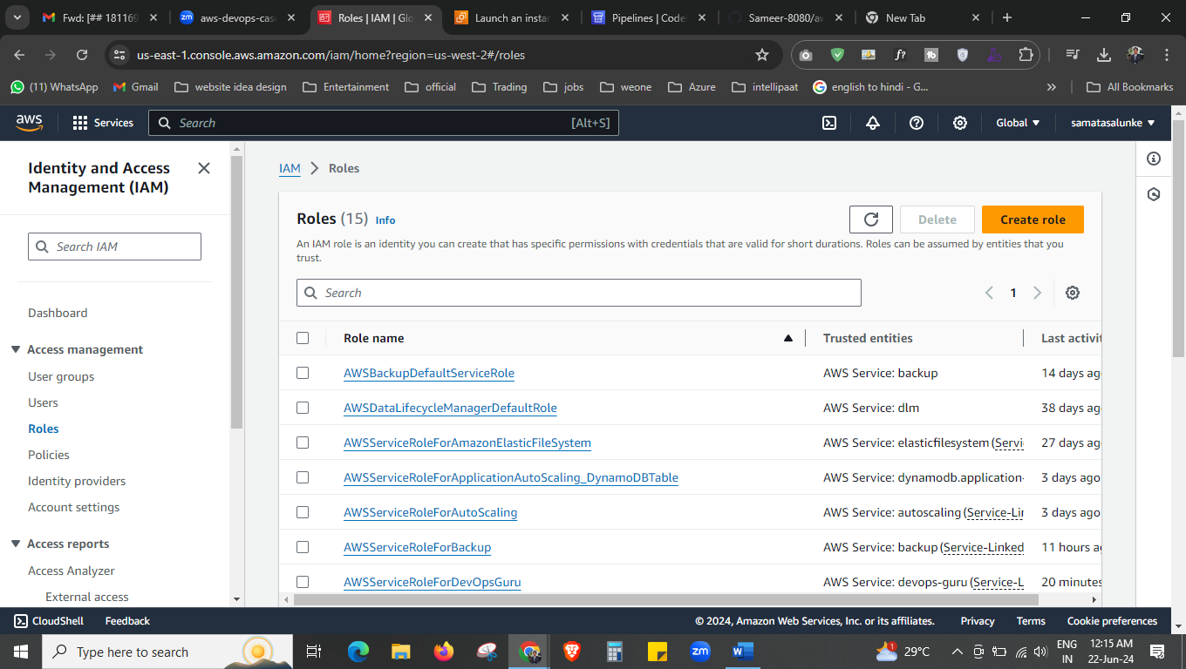



First, we will be creating the Roles. So that service can communicate with other service, here we are creating the role so that the ec2 can communicate with [AdministratorAccess-AWSElasticBeanstalk](https://us-east-1.console.aws.amazon.com/iam/home?region=us-west-2#/policies/details/arn%3Aaws%3Aiam%3A%3Aaws%3Apolicy%2FAdministratorAccess-AWSElasticBeanstalk), [AmazonS3FullAccess](https://us-east-1.console.aws.amazon.com/iam/home?region=us-west-2#/policies/details/arn%3Aaws%3Aiam%3A%3Aaws%3Apolicy%2FAmazonS3FullAccess), [AWSCodeDeployFullAccess](https://us-east-1.console.aws.amazon.com/iam/home?region=us-west-2#/policies/details/arn%3Aaws%3Aiam%3A%3Aaws%3Apolicy%2FAWSCodeDeployFullAccess), [AdministratorAccess](https://us-east-1.console.aws.amazon.com/iam/home?region=us-east-2#/policies/details/arn%3Aaws%3Aiam%3A%3Aaws%3Apolicy%2FAdministratorAccess)

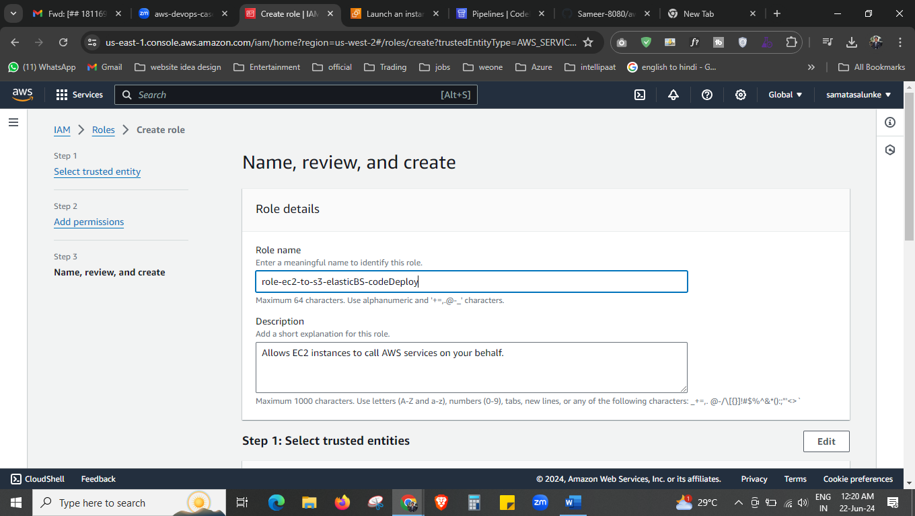

Give the name to the role.

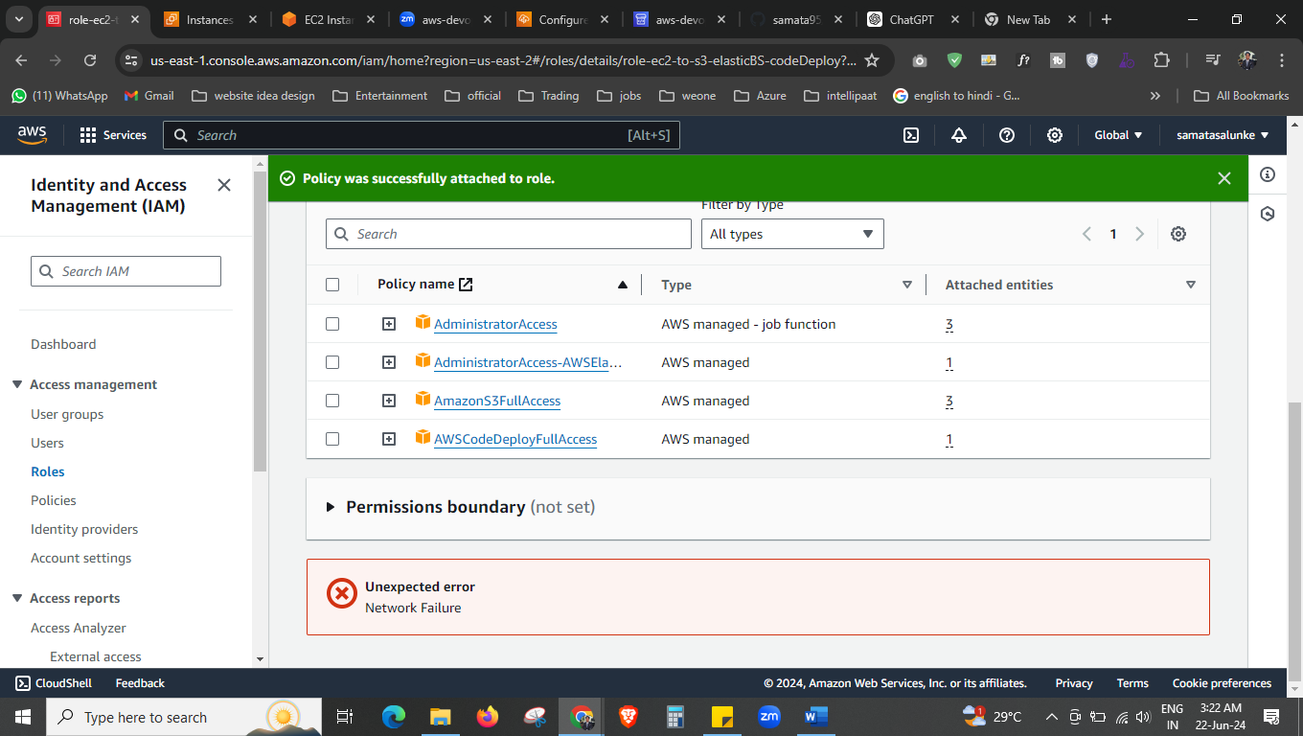



Click on create role.

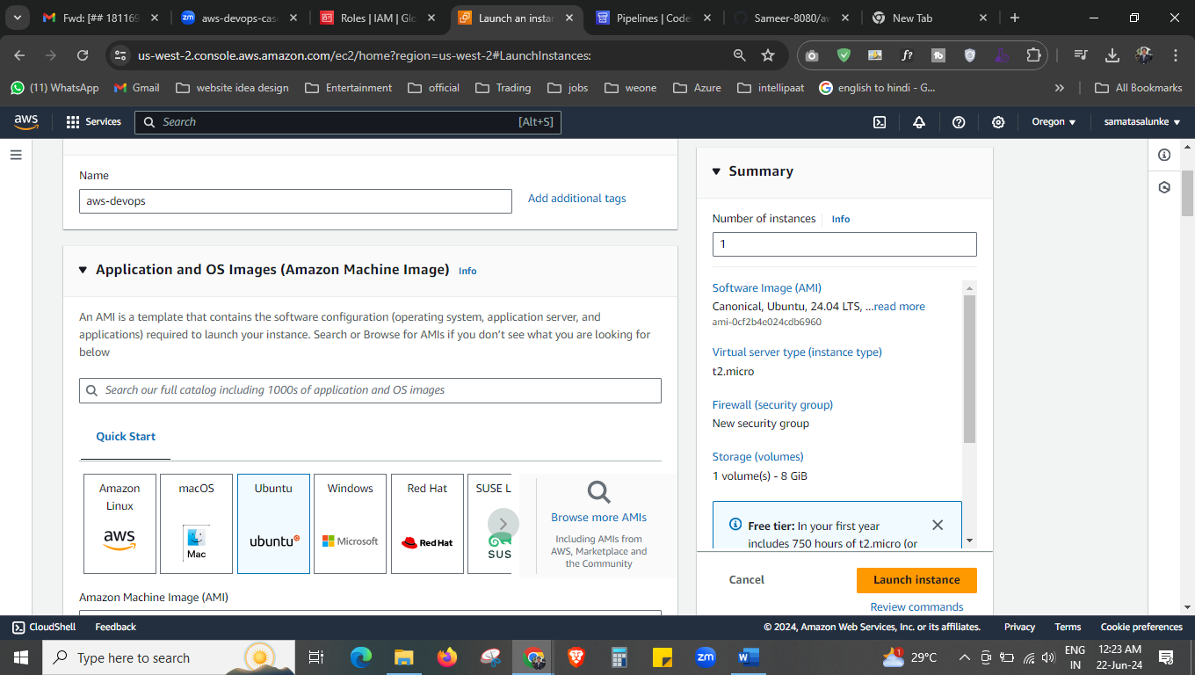

Now create the ec2 instance.

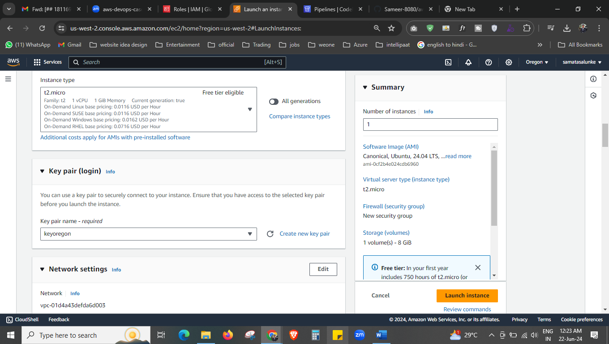

Select the instance type and key

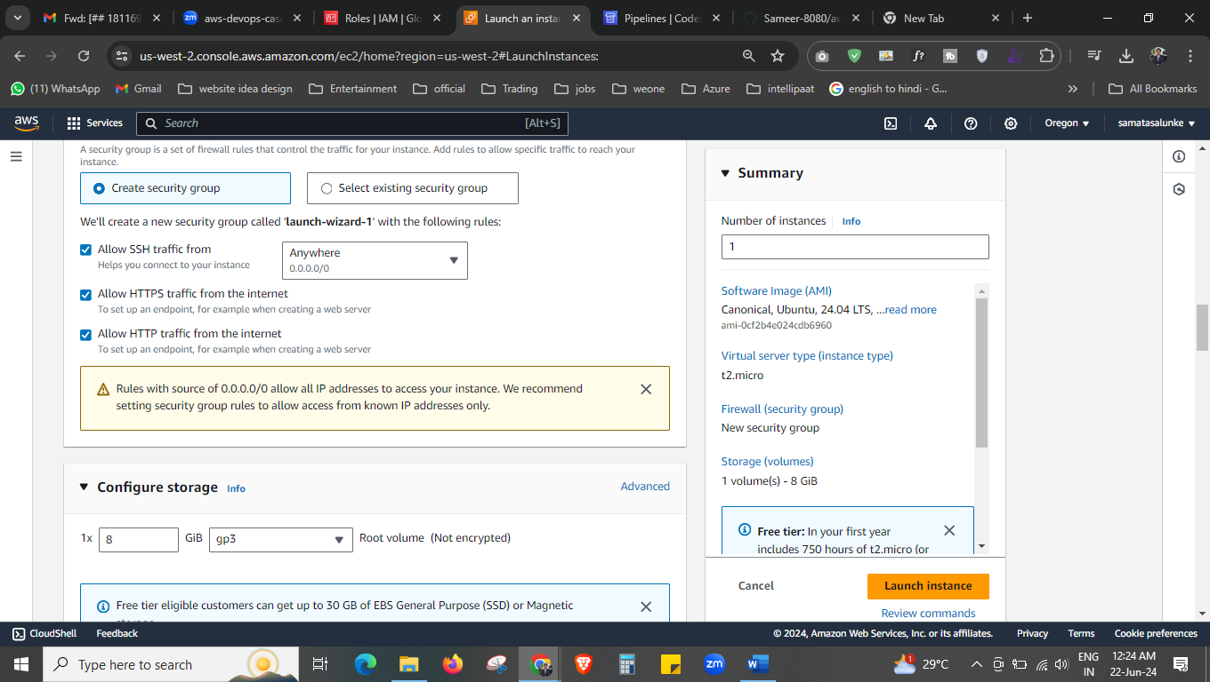

Select the security group and allow all traffic.

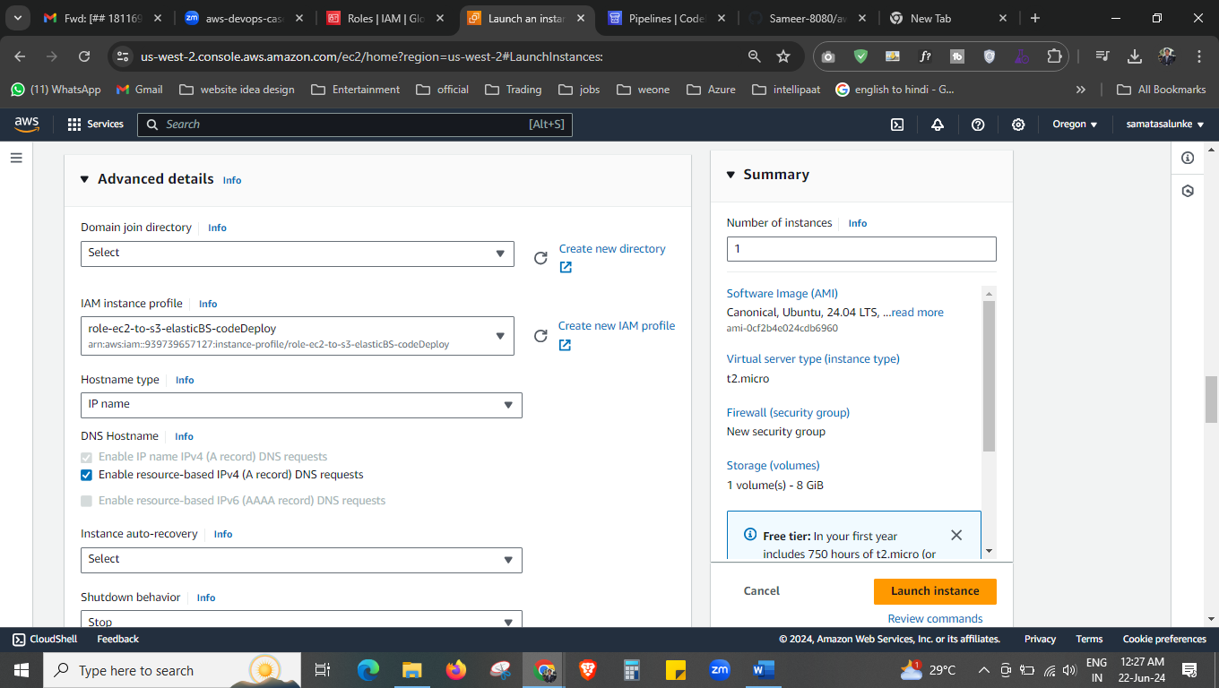



Select the role that we have created and launch the instance.

1 clear

2 sudo apt update

3 sudo apt install ruby-full

4 sudo apt install wget

5 ls

6 https://aws-codedeploy-us-east-2.s3.us-east-2.amazonaws.com/latest/install

7 wget https://aws-codedeploy-us-east-2.s3.us-east-2.amazonaws.com/latest/install

8 ls

9 chmod +x ./install

10 sudo ./install auto

11 systemctl start codedeploy-agent

12 systemctl status codedeploy-agent

13 history

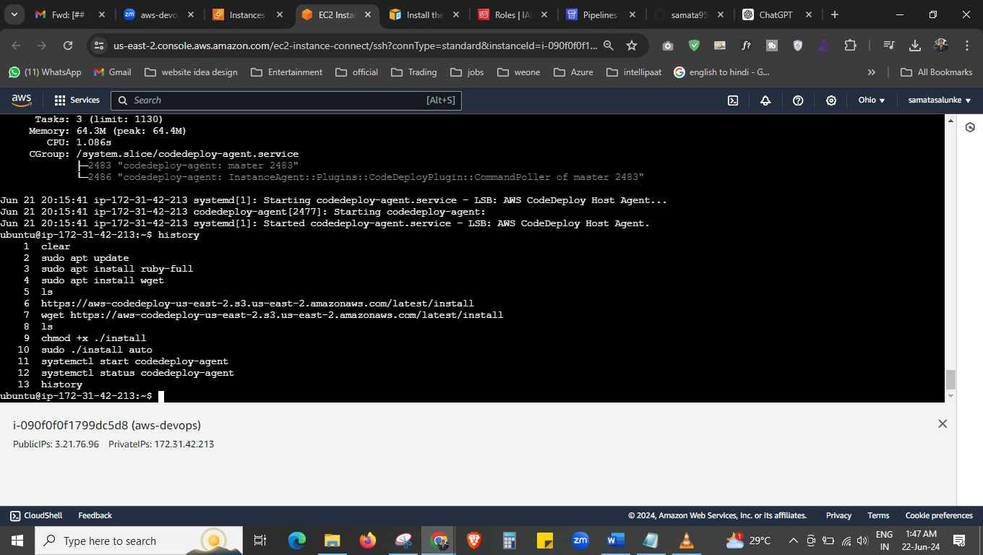

This is the commands we have used.

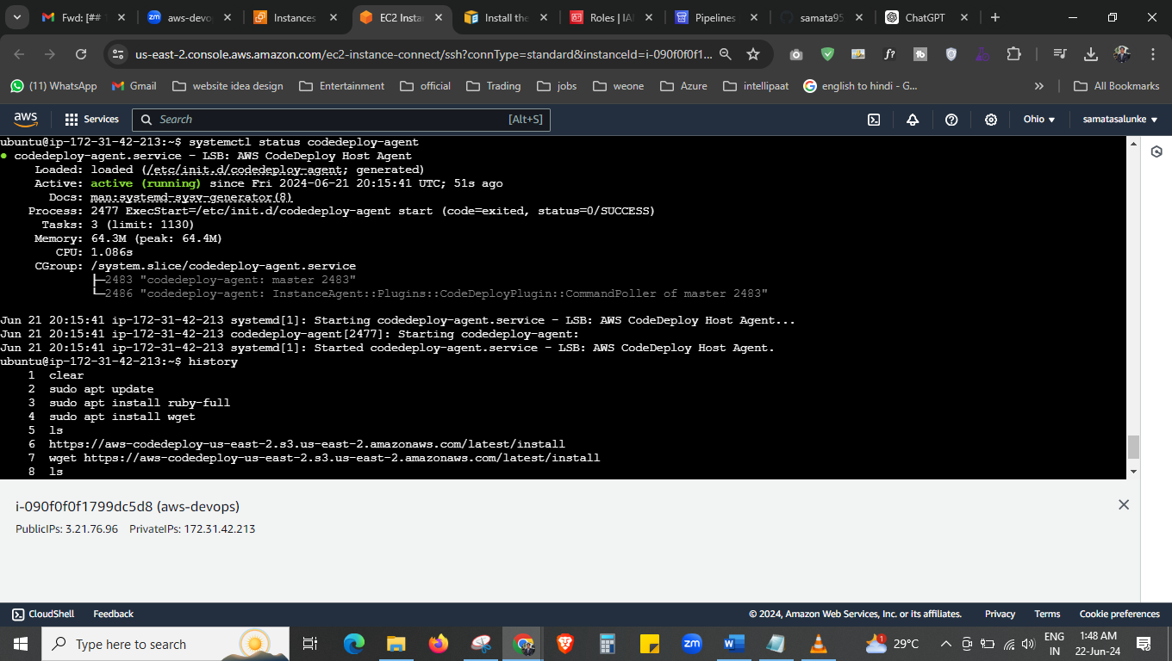

Now its running.

﻿systemctl start codedeploy-agent

systemctl status codedeploy-agent

check the status first if its not running then run it.

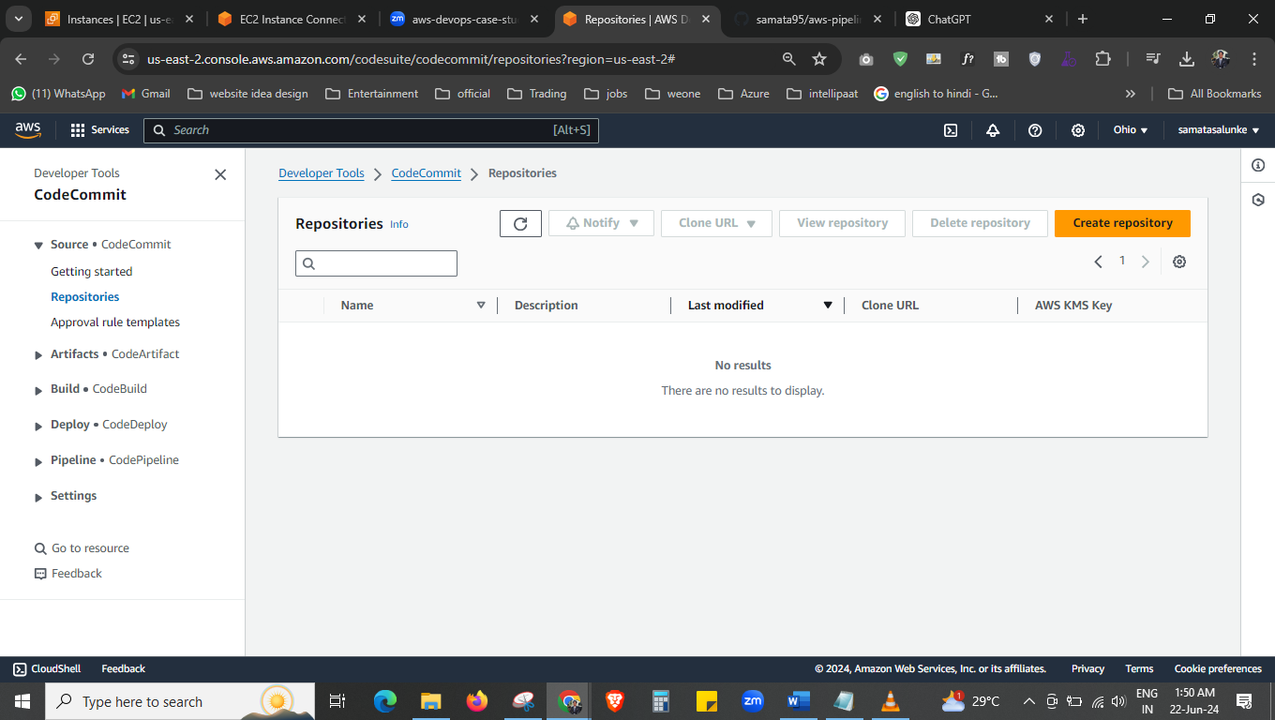

Now go to the code commit > repositories

Now create the repositories.

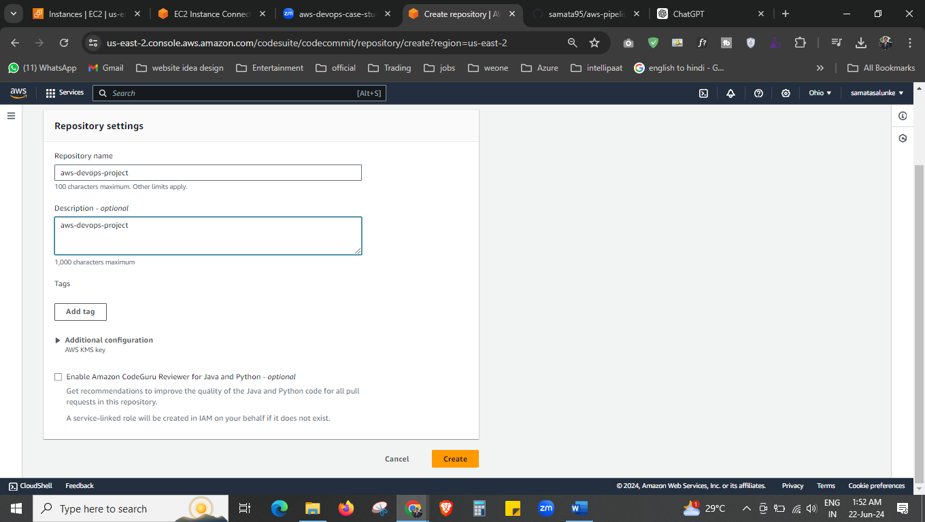



Give the repo name and create it.

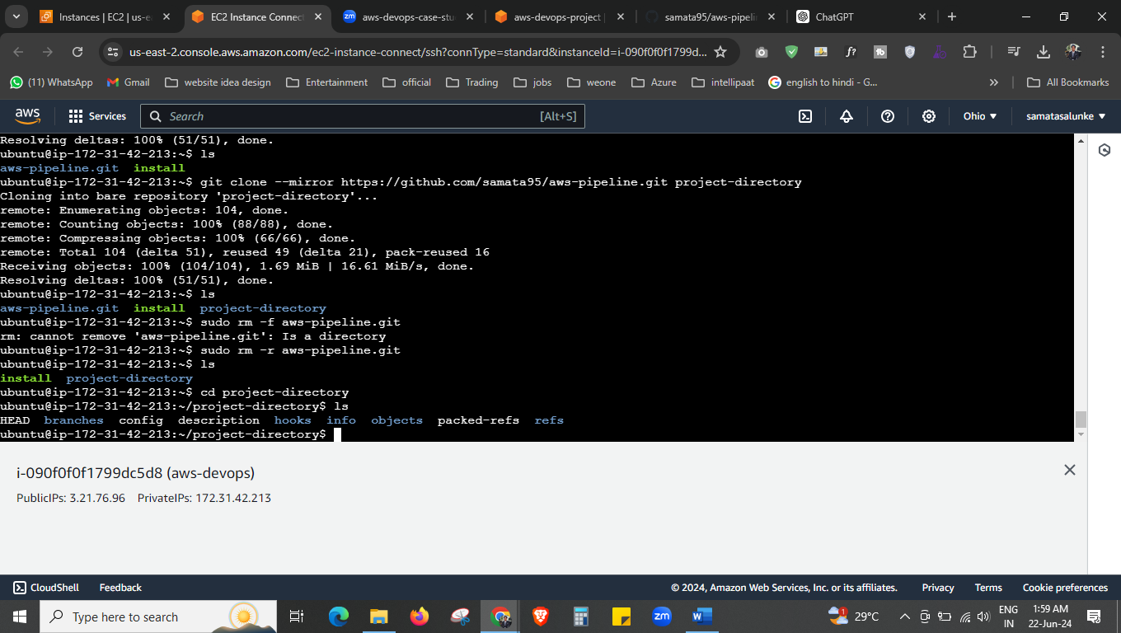

Now we have push the repo from github to aws ec2 instance.

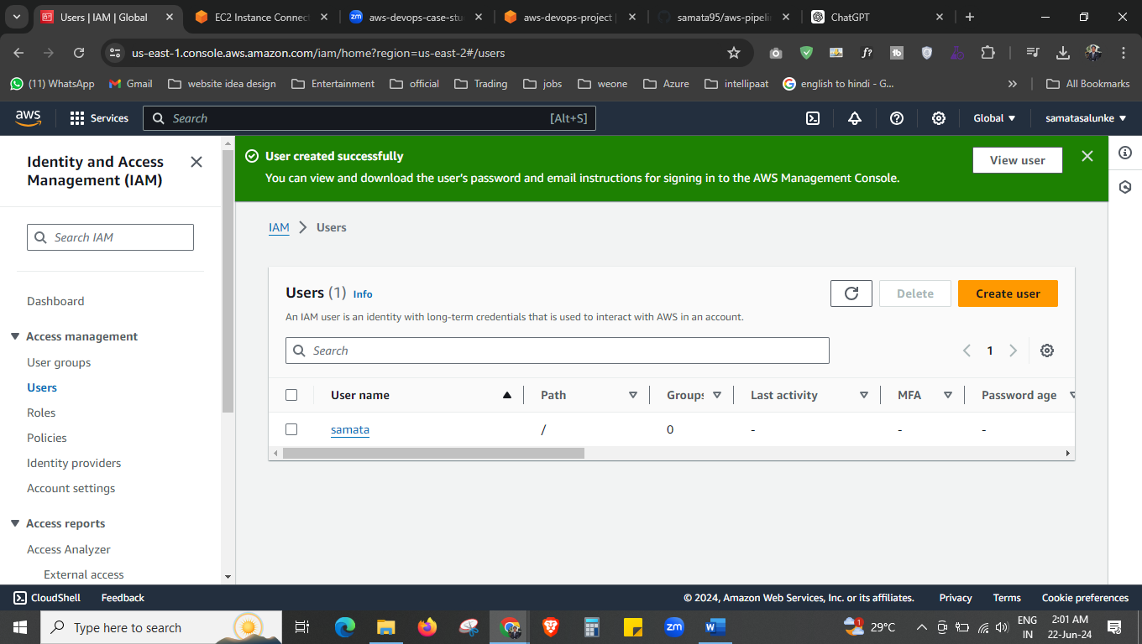



I we want to push this repo from ec2 instance to our aws devops pipeline console, to do that we need to create the username and password. Click on the user name and go inside.

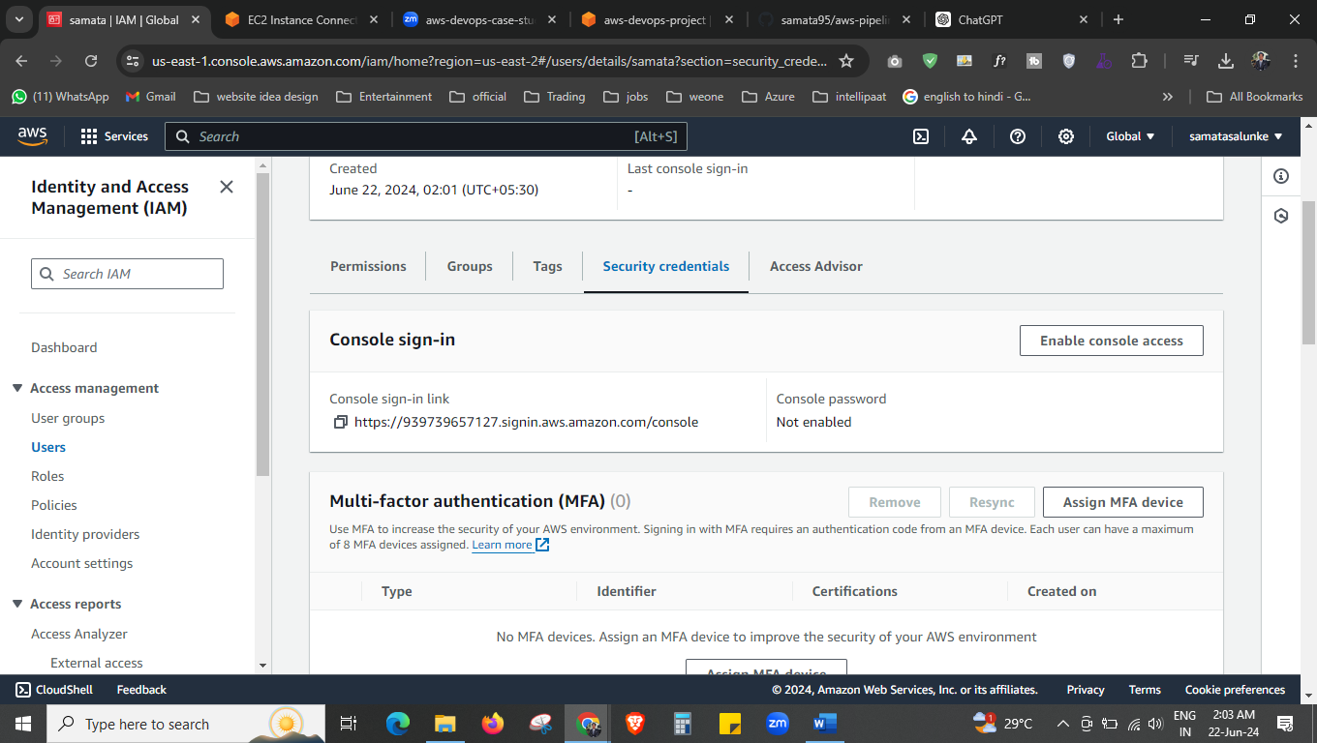

Go to the “security credentials”

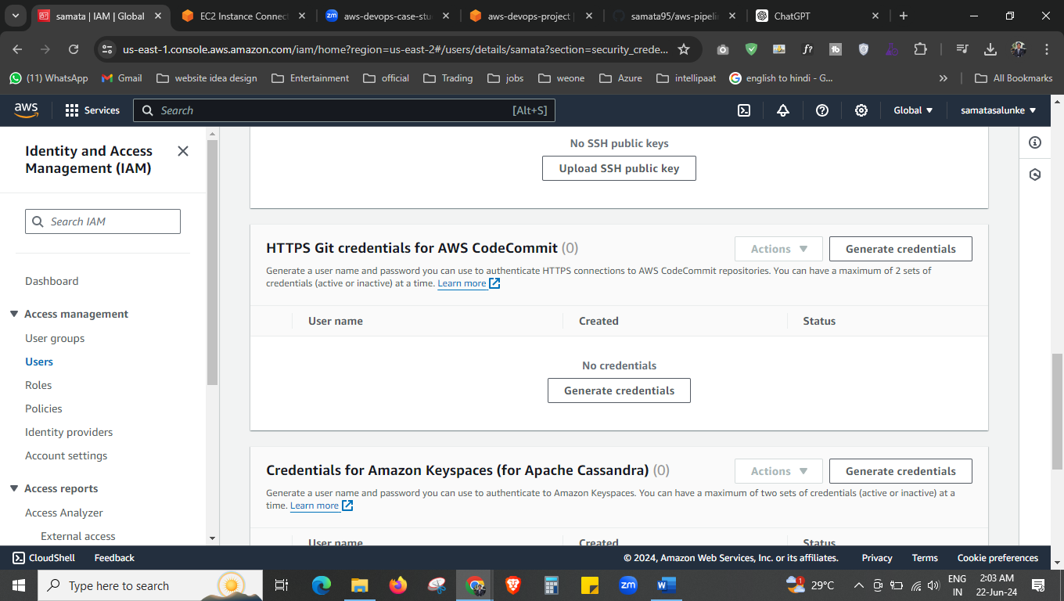



Click on **Generate credentials.**

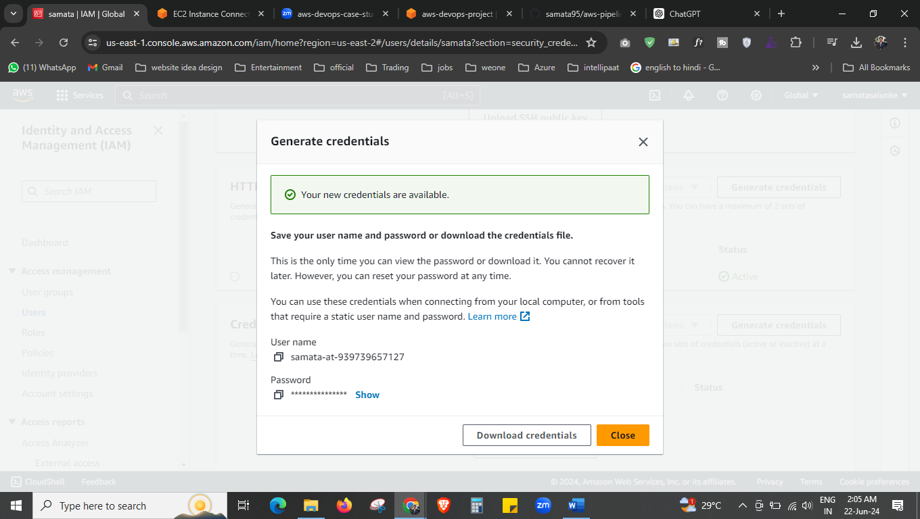

And you can see out credential with password here.

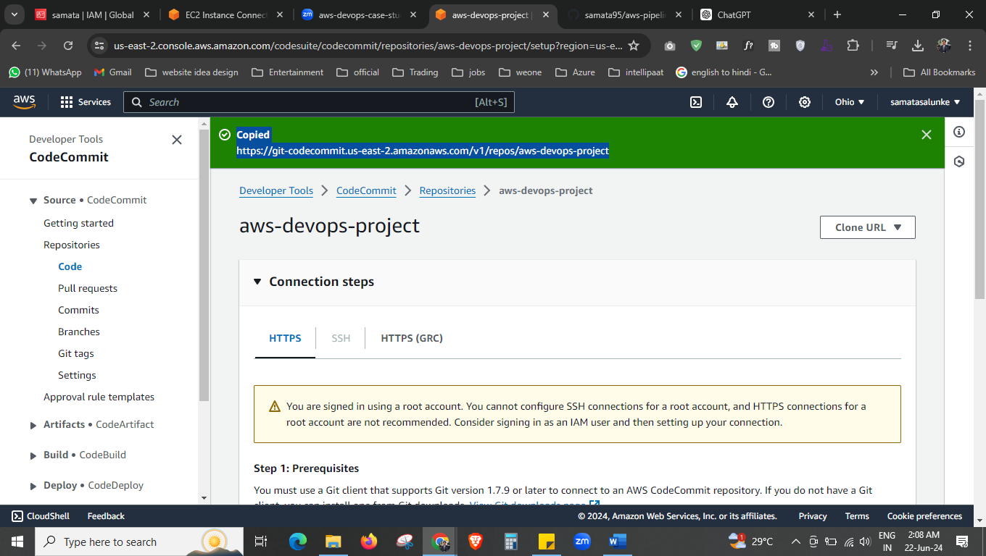

Now copy this link.

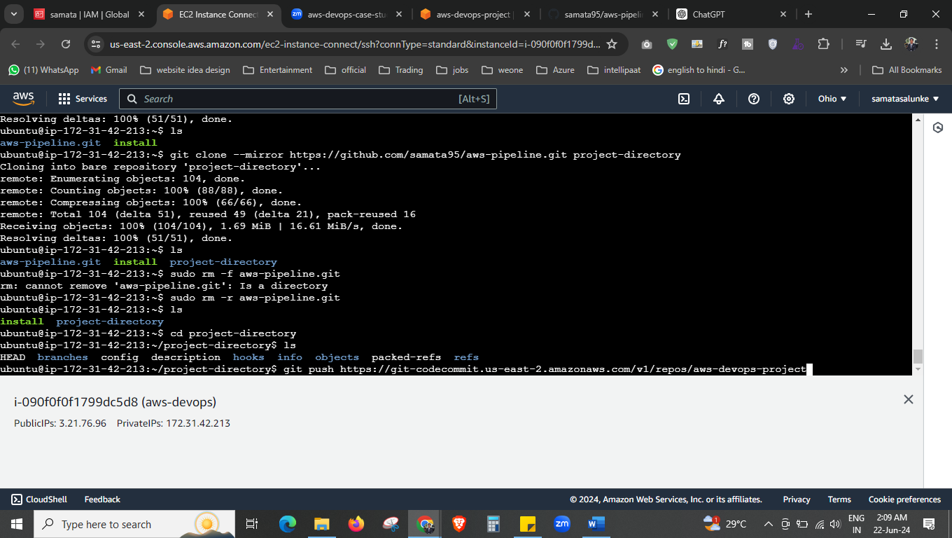



Now paste the link here, with this link we can push the repo from ec2 instance to aws devops repo.

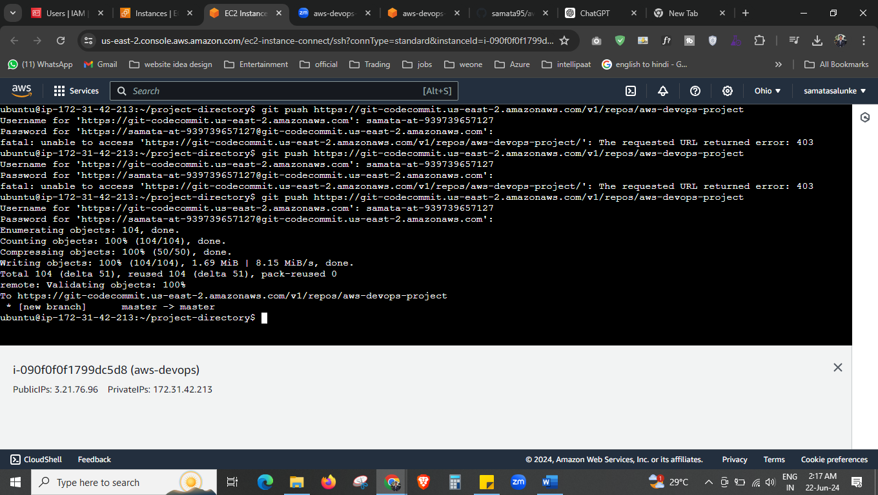



Now this repo in pushed to aws repo.

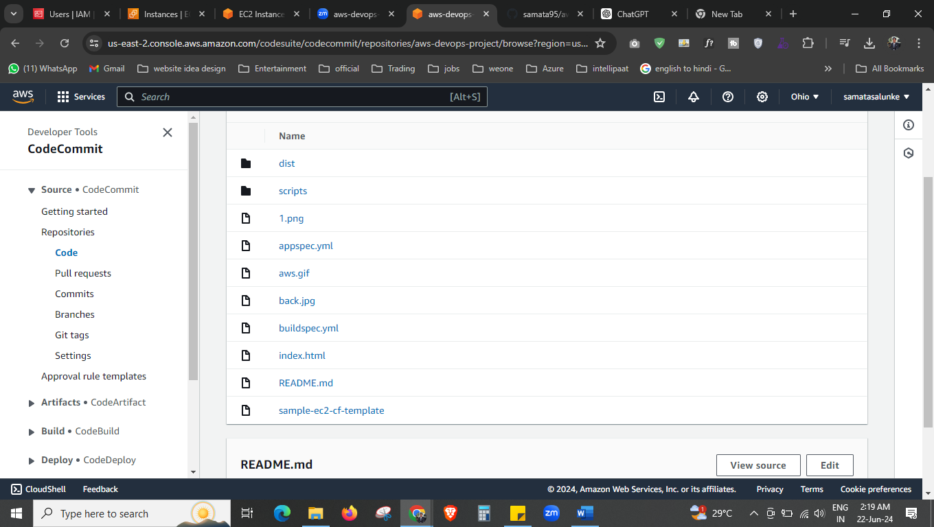

This is the repos which we had transferred.

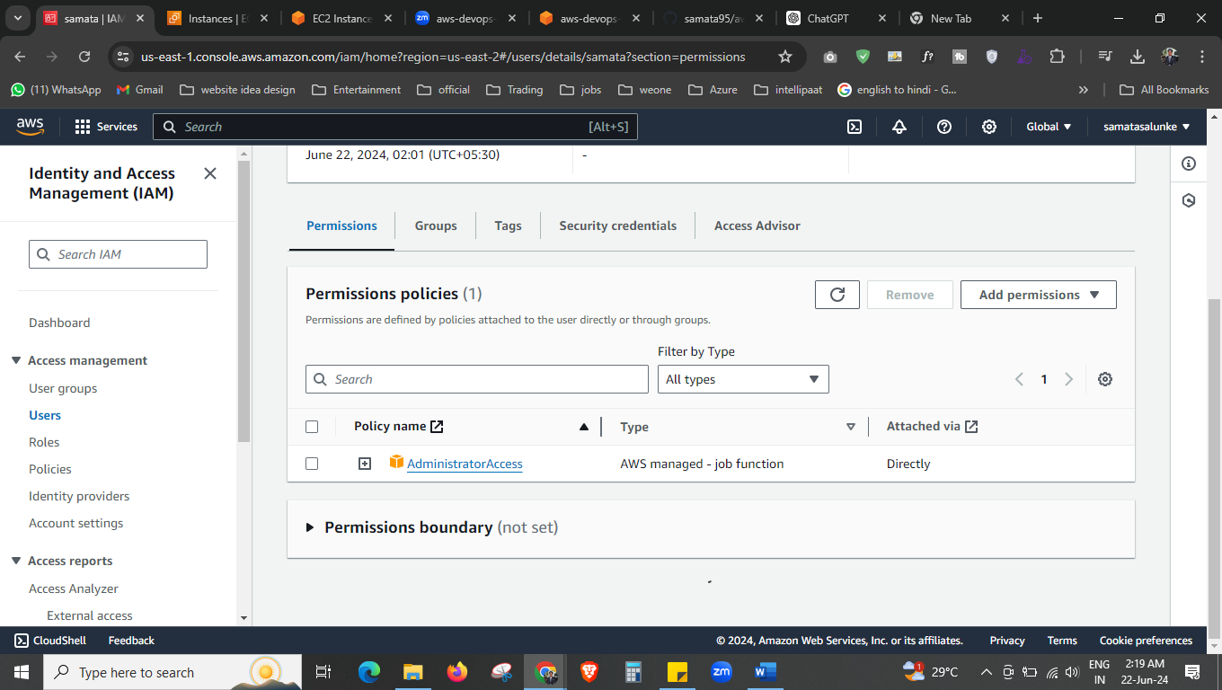

Make sure, user has a “AdministratorAccess” permission. Only then your username and password will work.

Now go to pipeline.

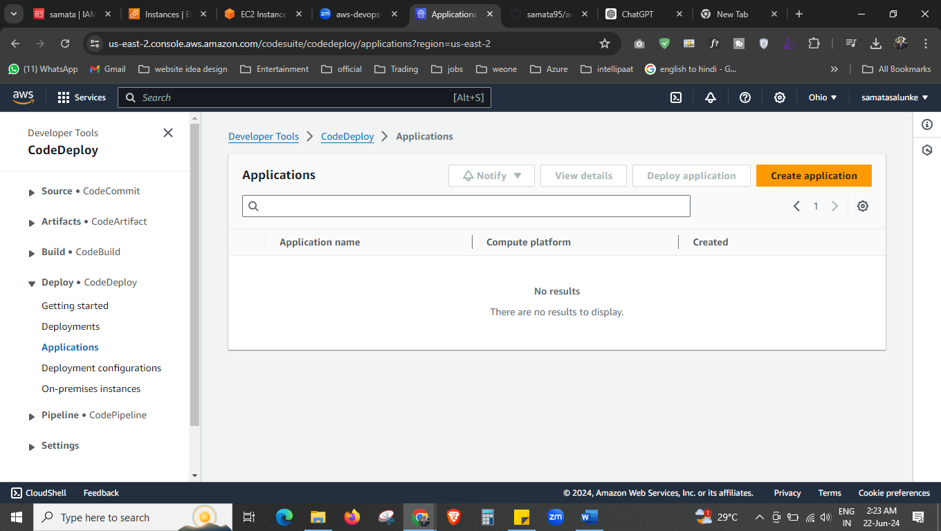

Now create the “application” first.

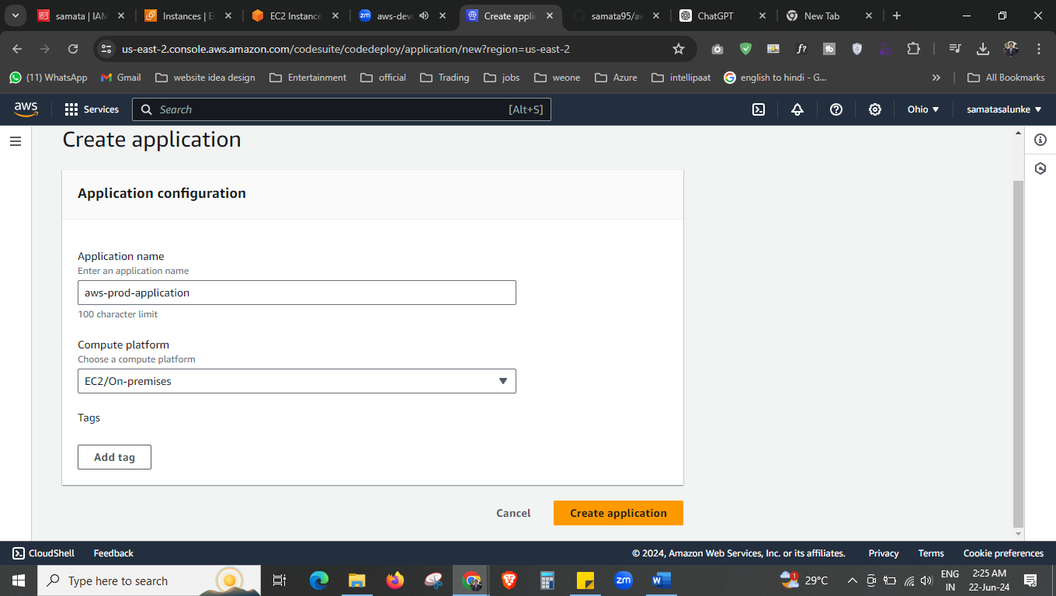



Give the application name and compute platform, create the application

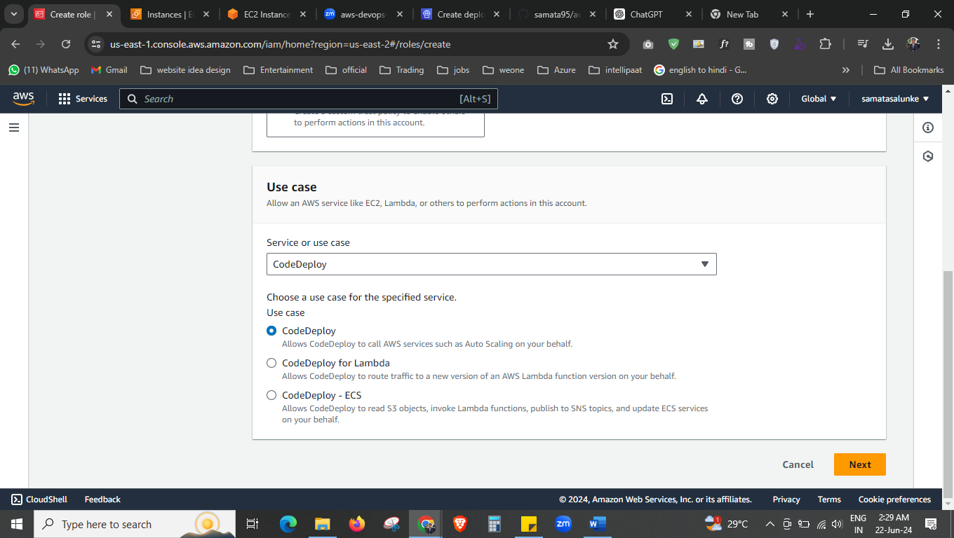

Now give the permission, create the roles.

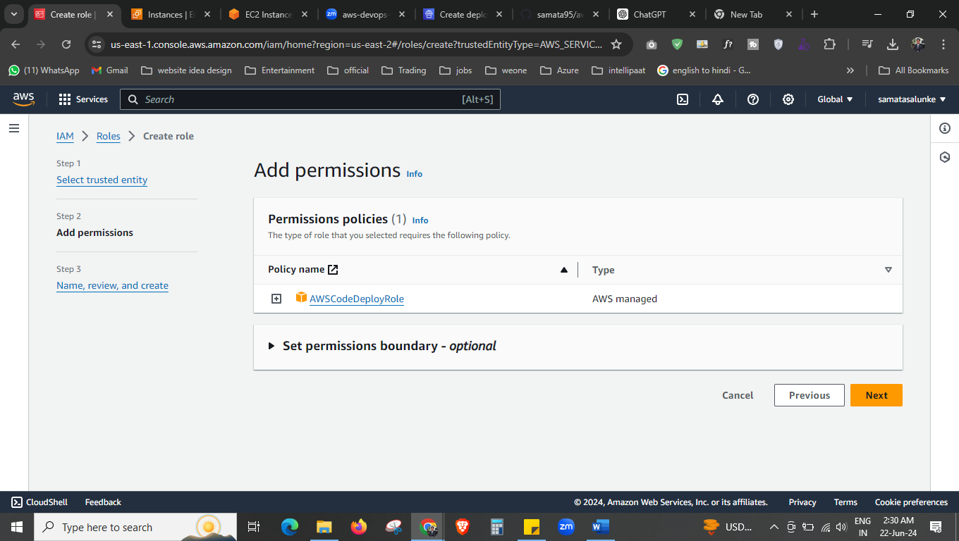

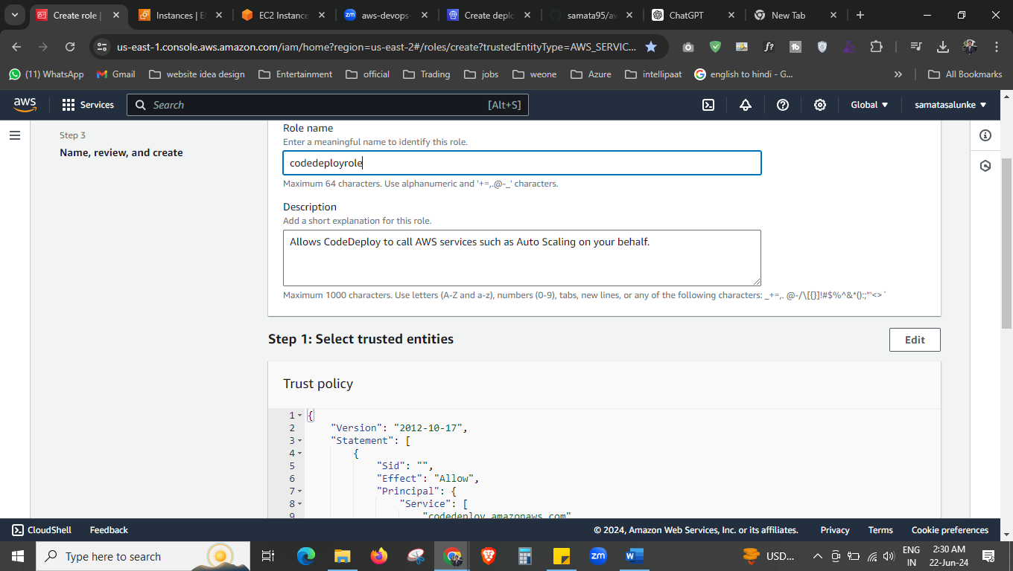

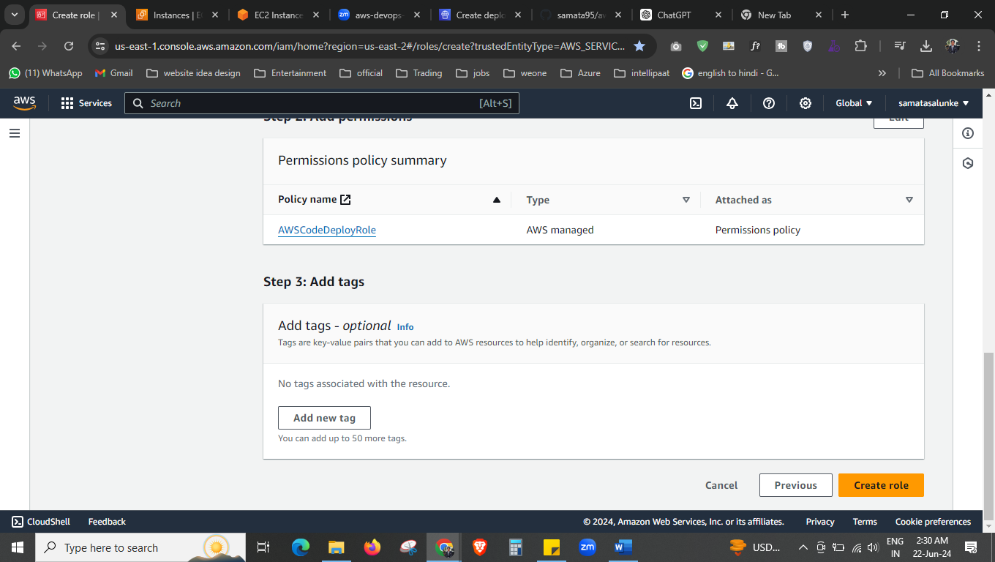



Then we have created the role.

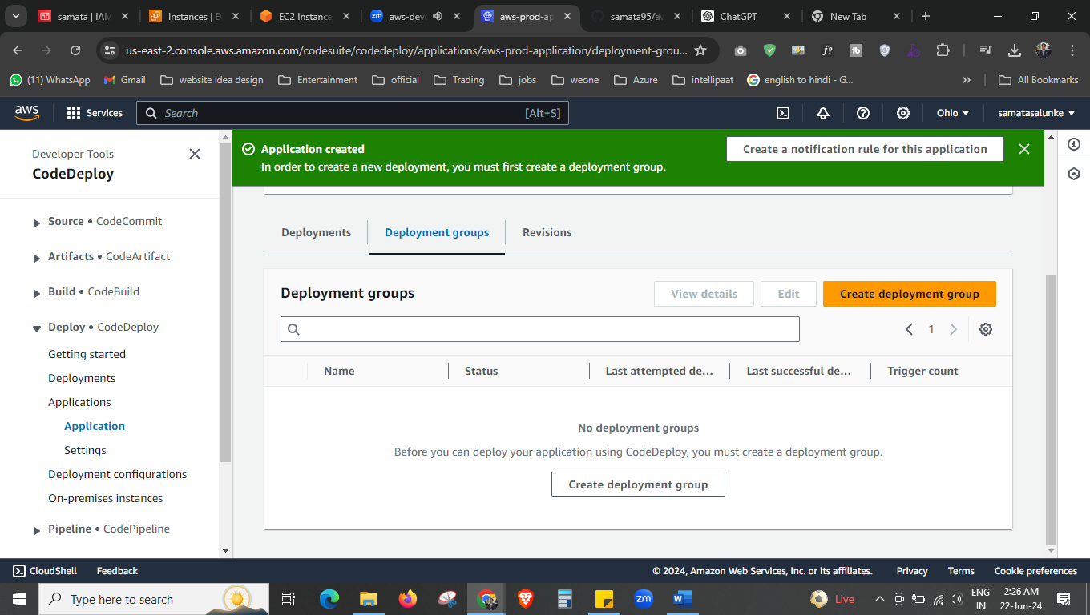

After application is created now we have to create the deployment group.

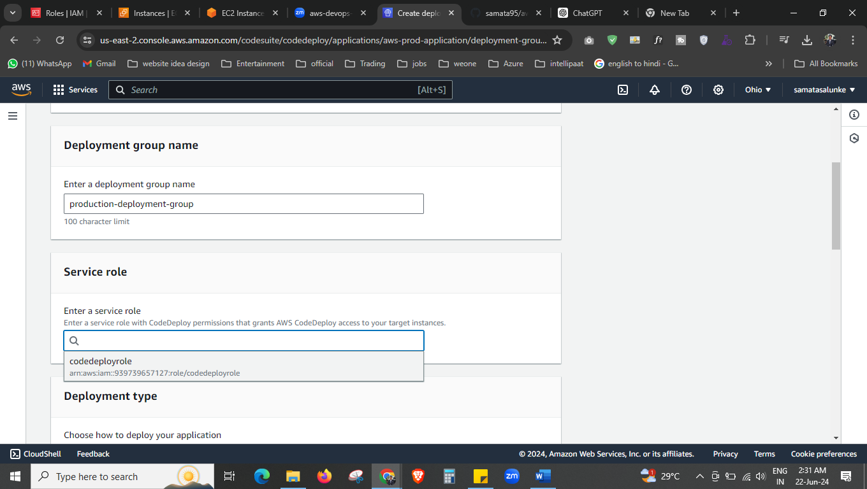give the name and select the role that we have created.



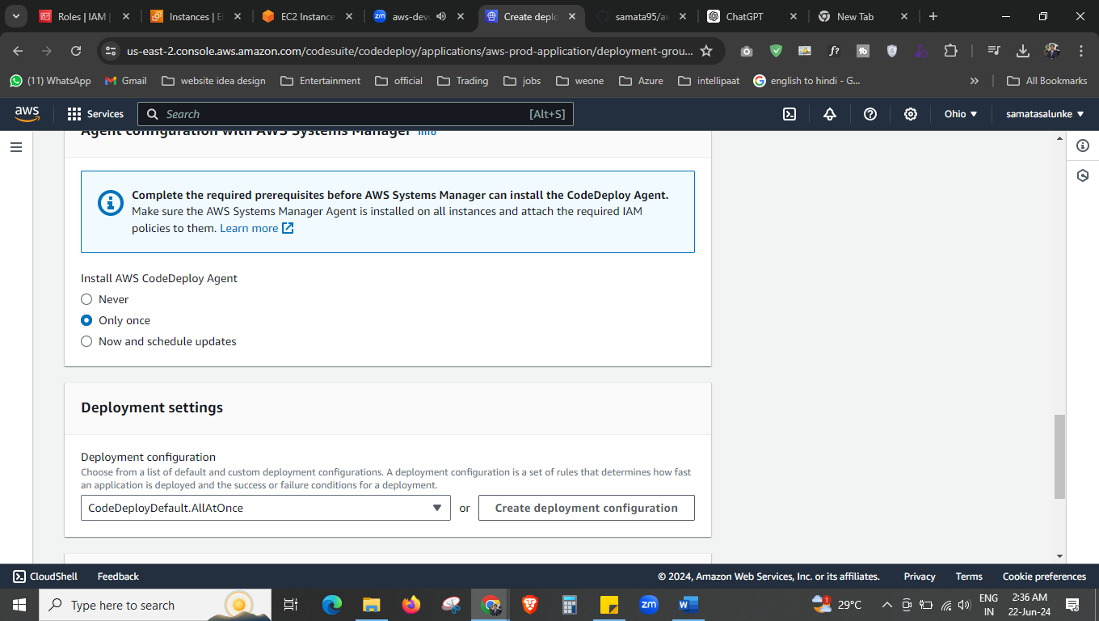

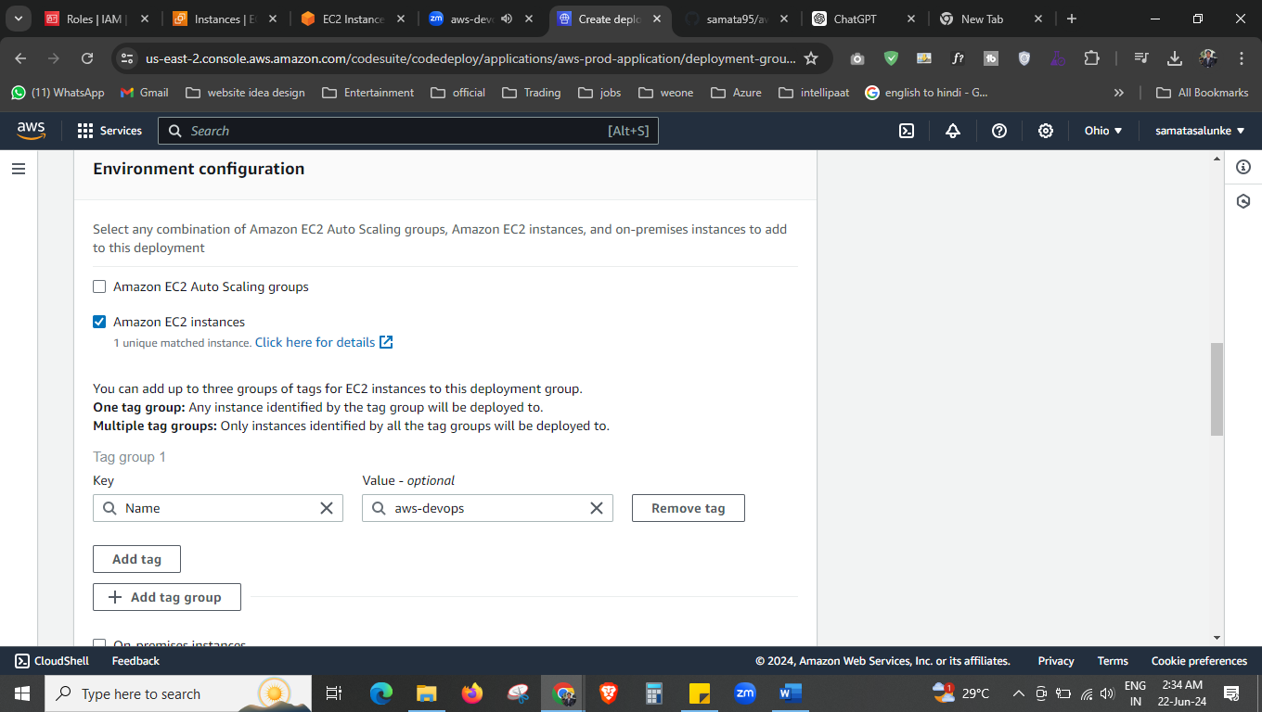



Select the ec2 instance, and select the instance you want to use here.

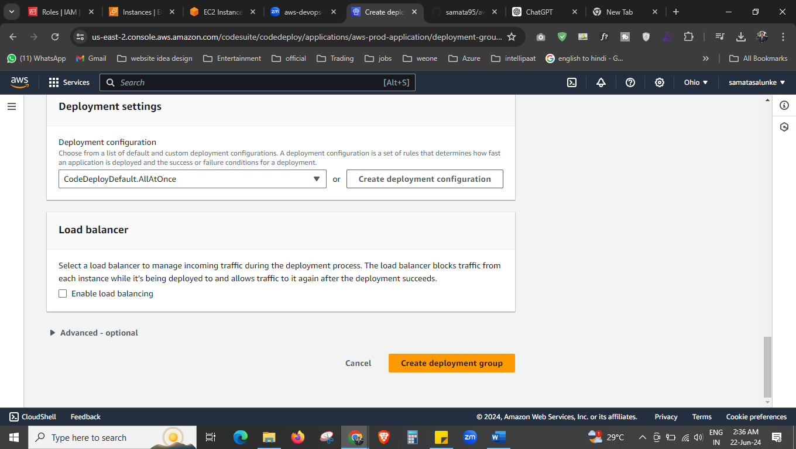



We don’t want any load balancer, create the deployment group.

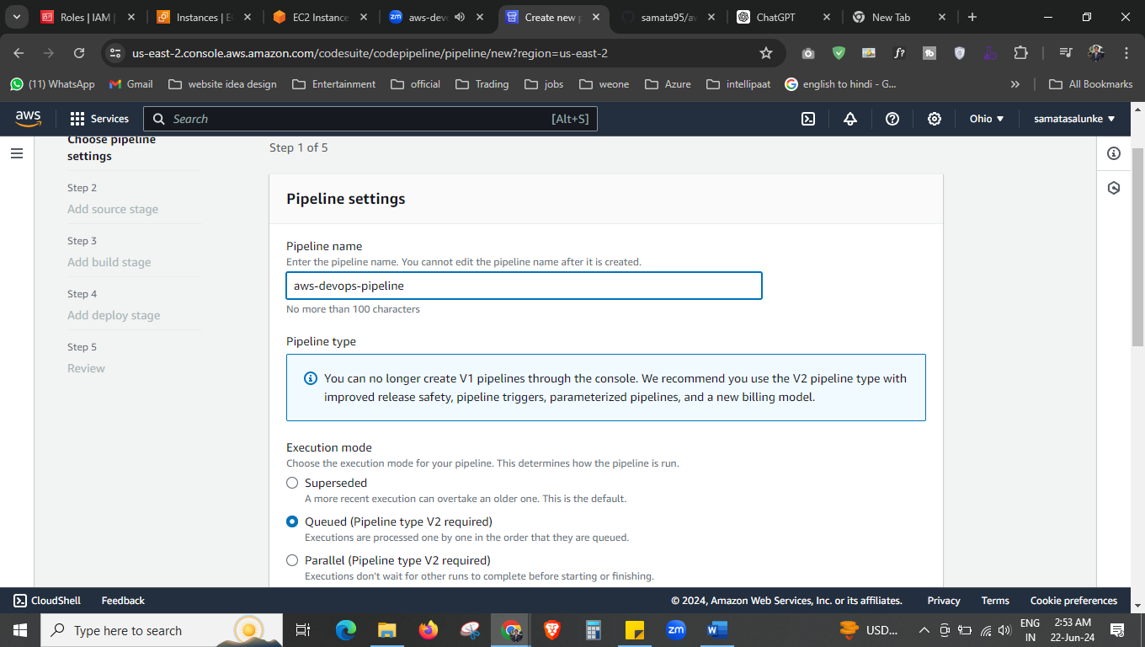



Now creating the pipeline.

Give the pipeline name.

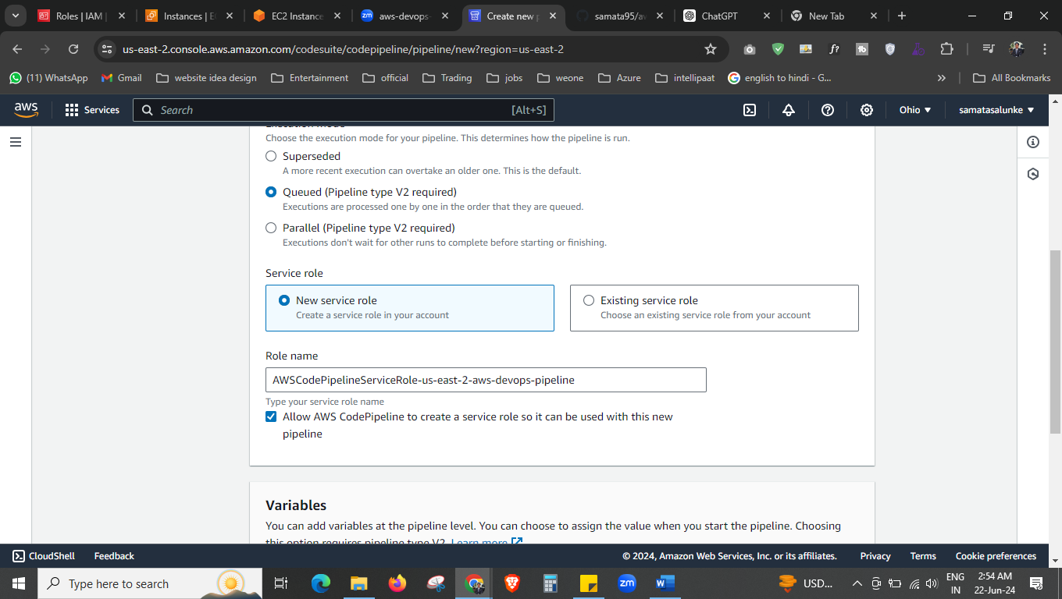



Allow this service role to create by aws.

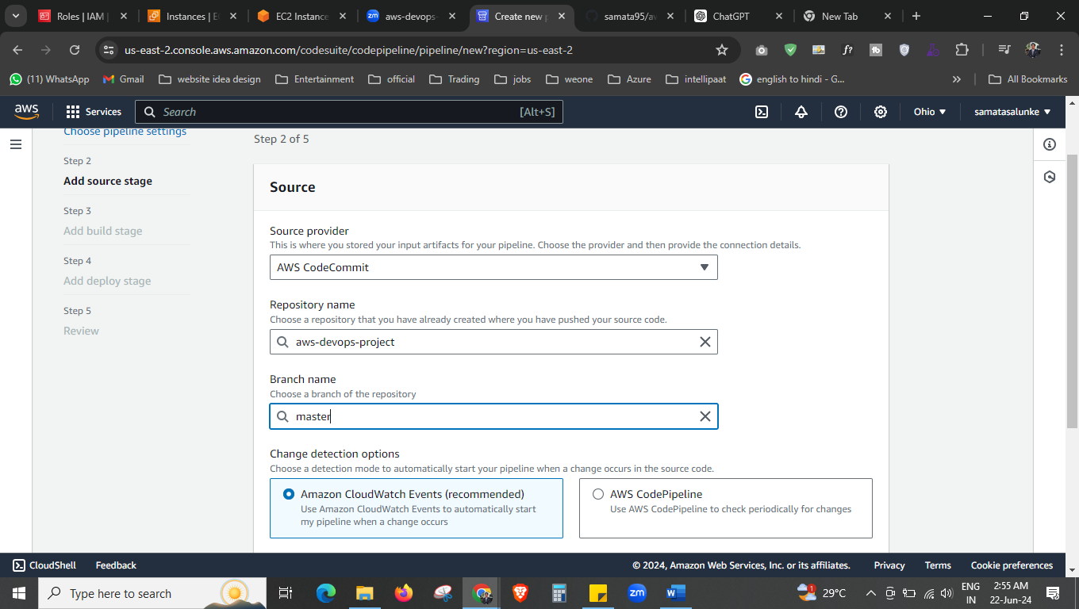

Select the “AWS codeCommit” as a source provide and select your repo that you created on aws devops then select the branch. Next

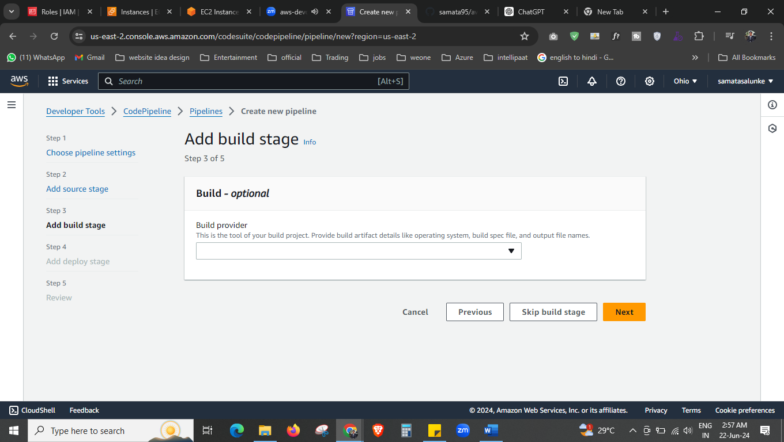

Skip this one, next

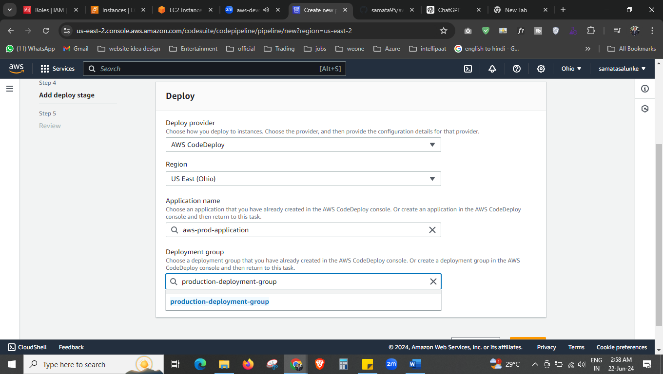

Select deploy provider as AWS codeDeploy

Select your application name, and select the deployment group.

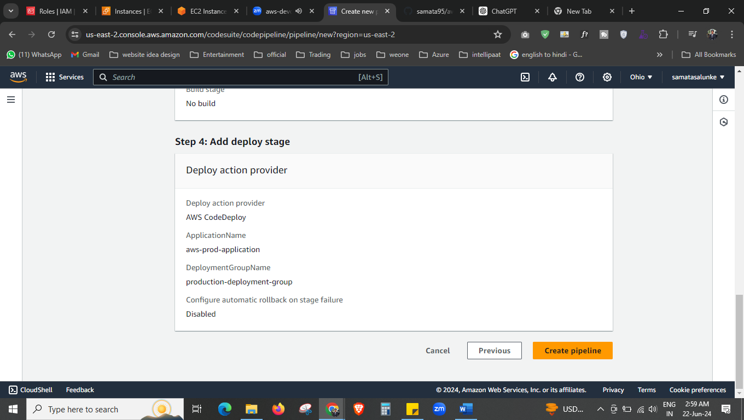

Then just create the pipeline.

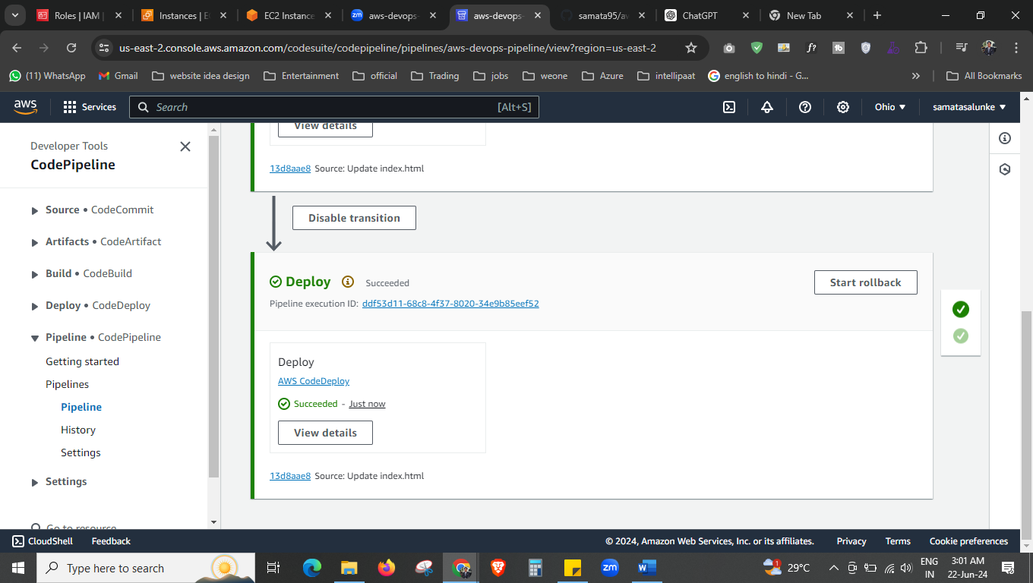now our pipeline is created successfully.

As per the project we have to create the elastic bean stalk also. So first we will create the role that we needed, then create the elastic beanstalk.

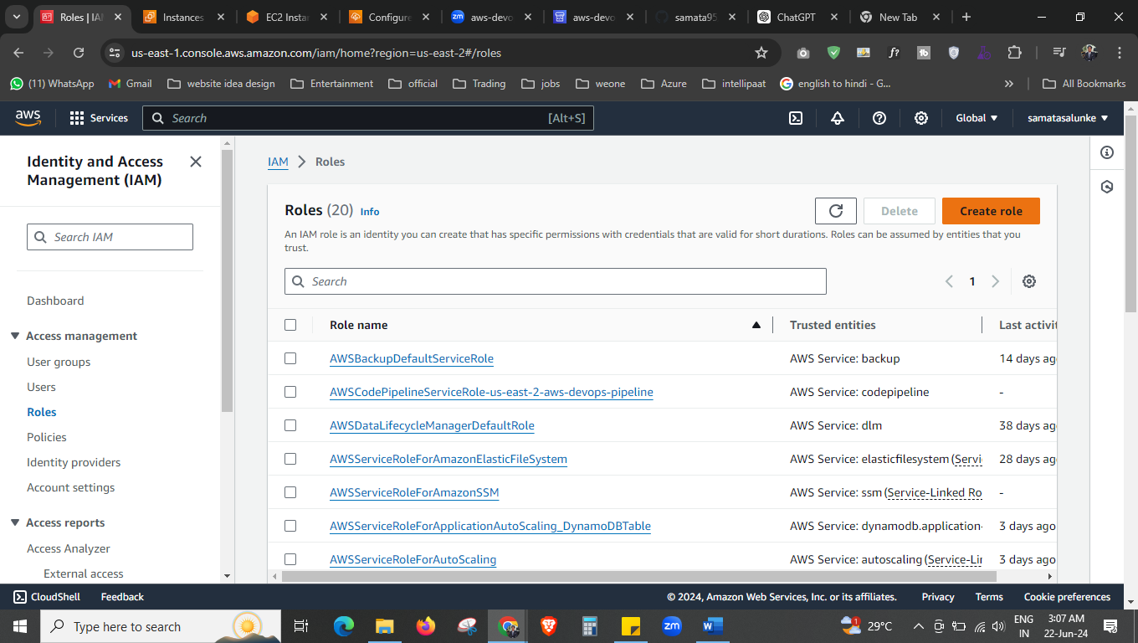



Create role

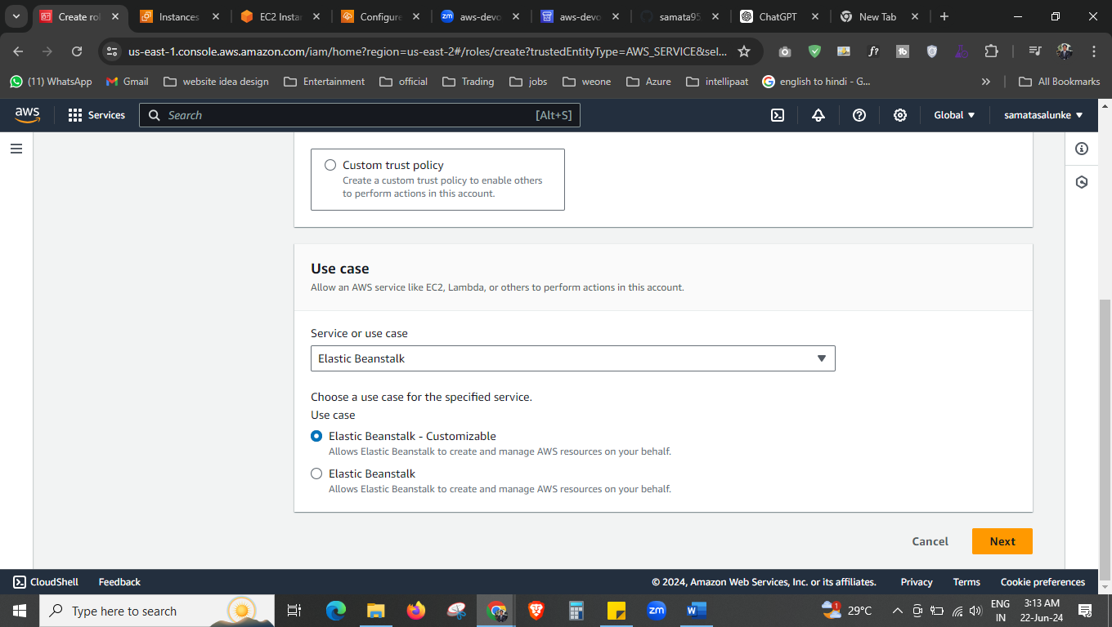



Select the elastic beanstalk first.

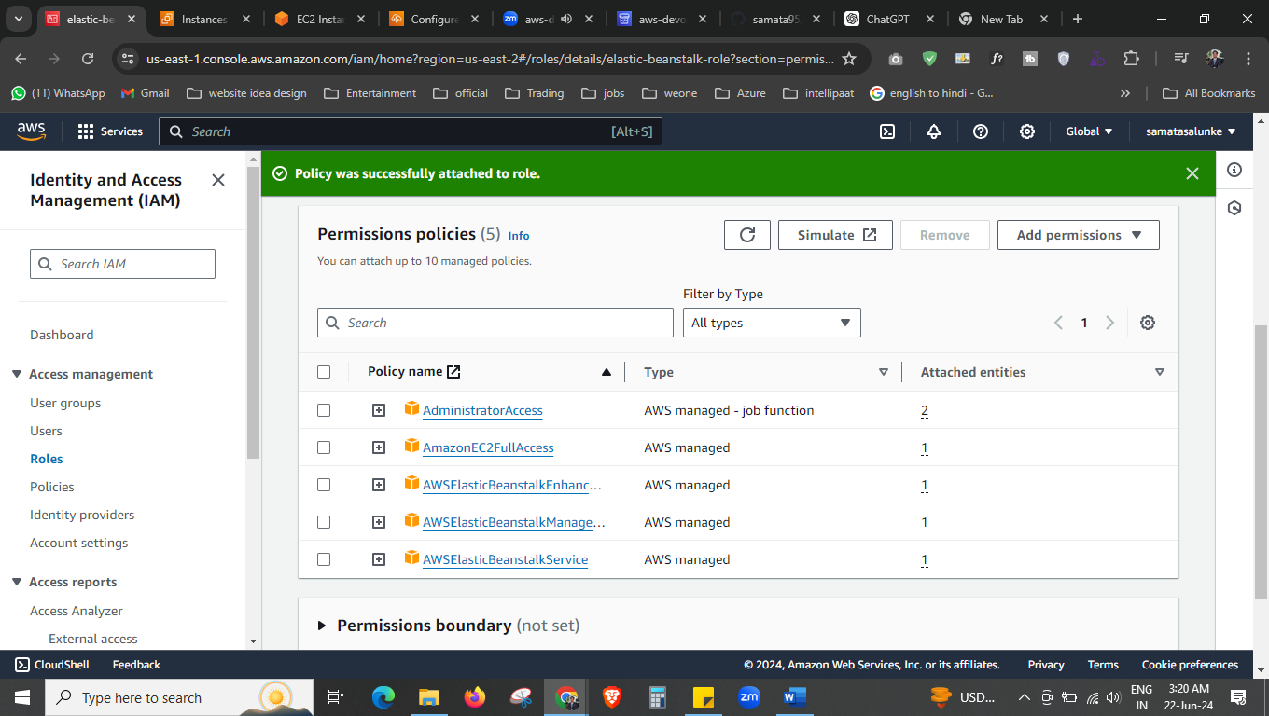

Give the permission, or may be it will already there for you.

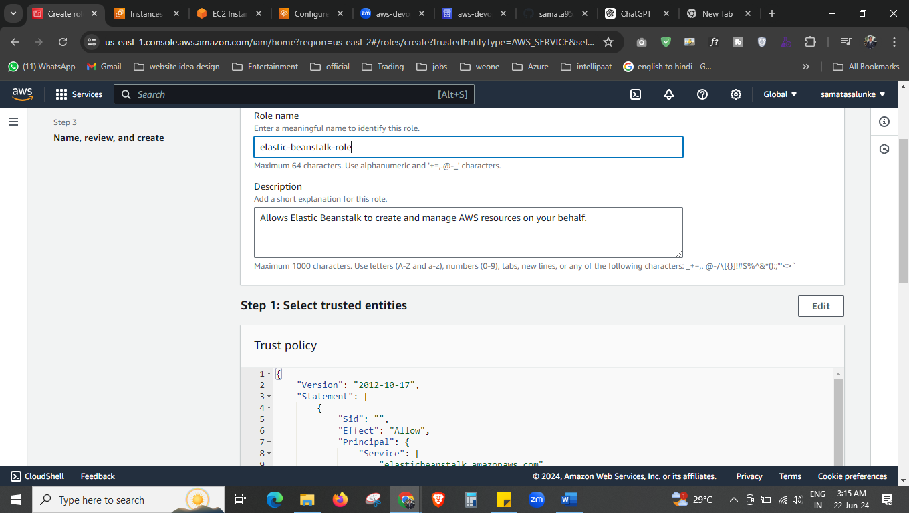



Give the name to your application.

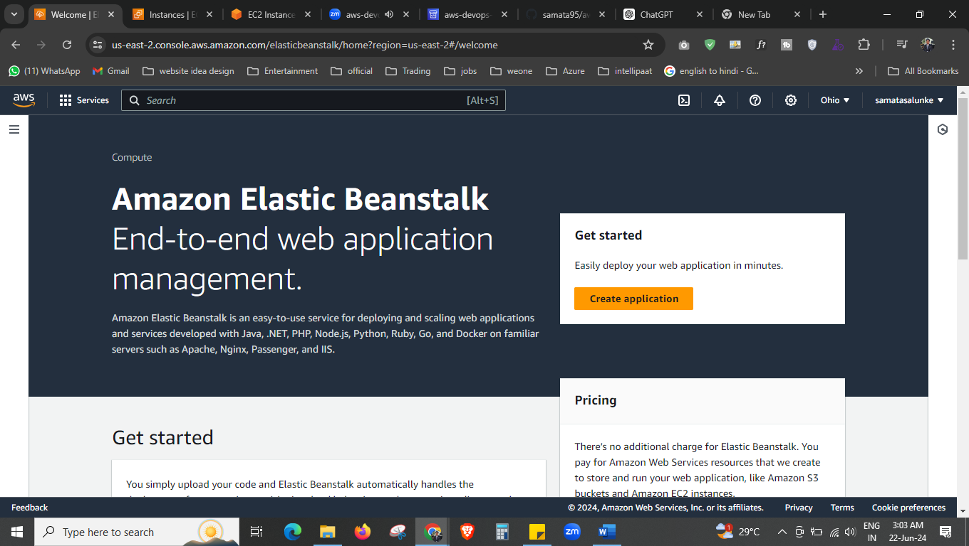



So now we will create the elastic bean stalk.

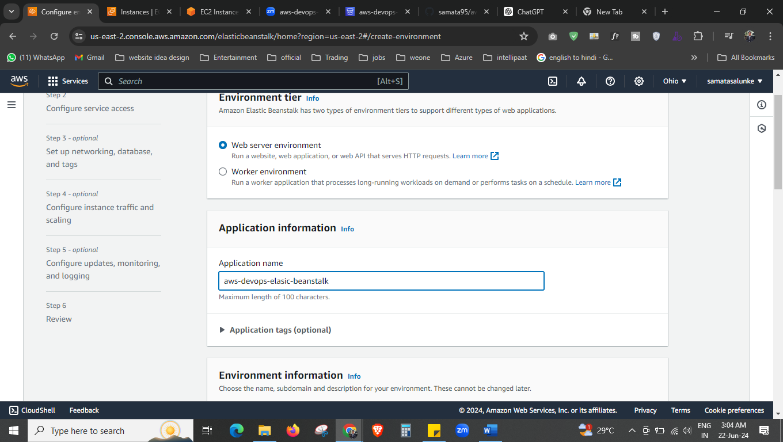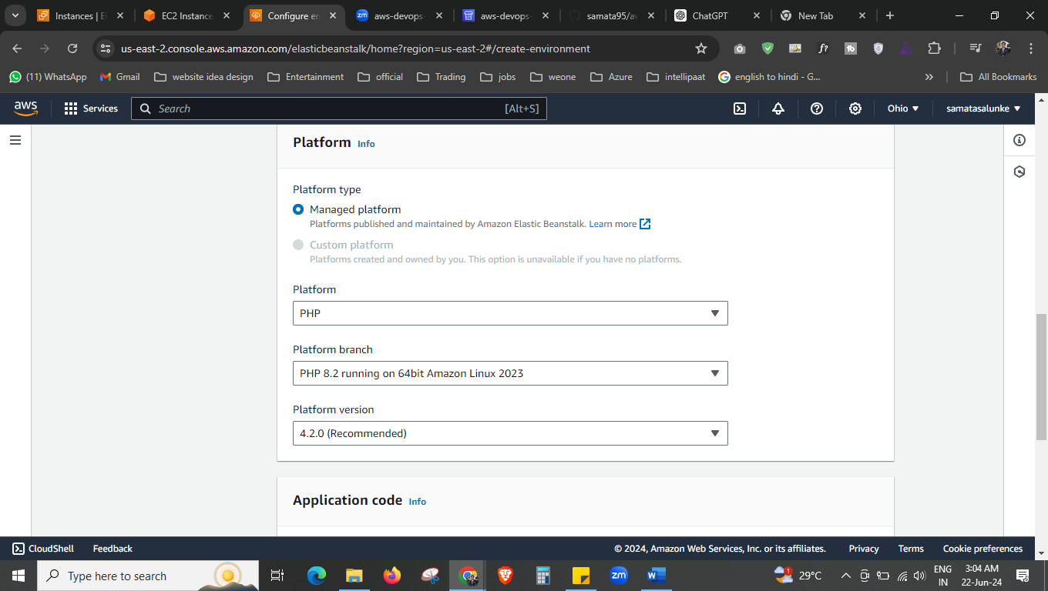

Here I select the PHP, we have PHP code. We can choose different one also if we have some other language project.

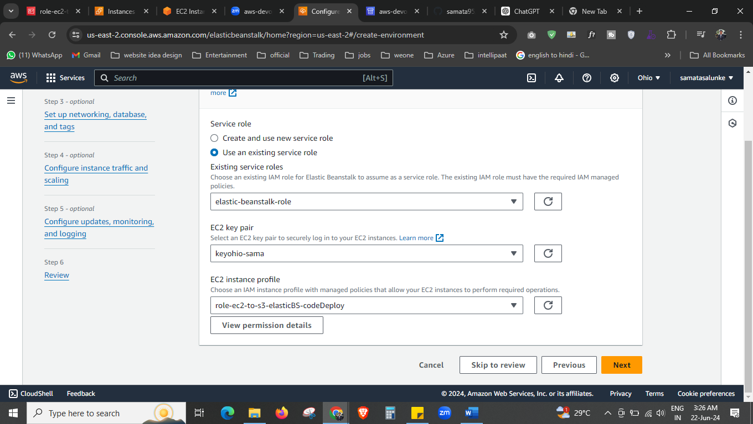

Select this all.

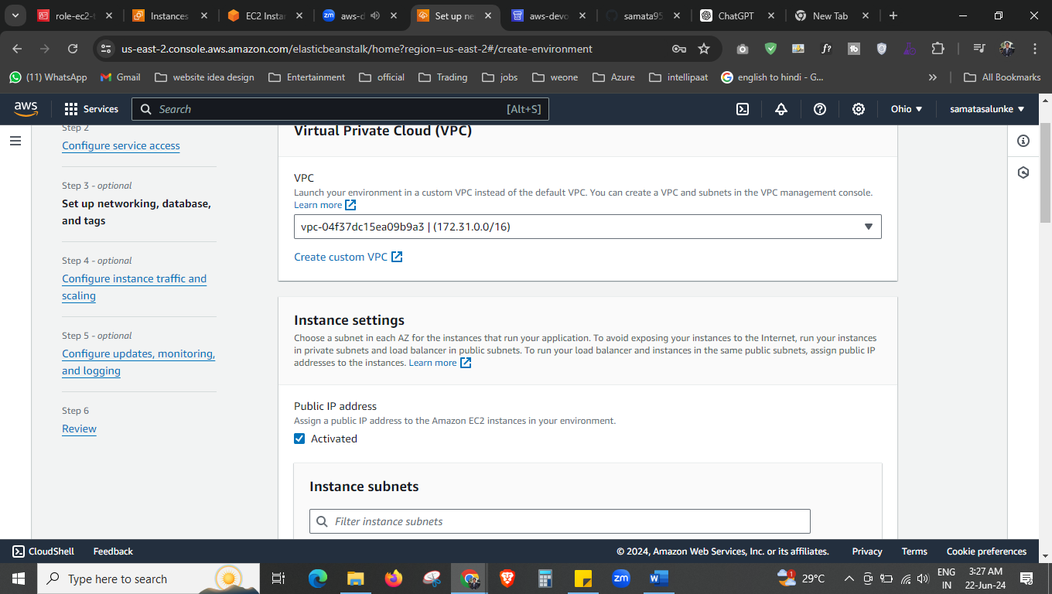



Select your vpc.

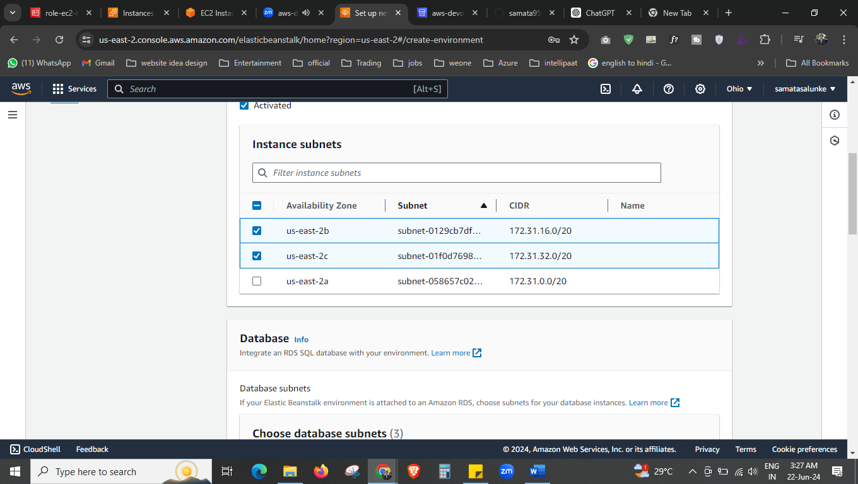

Choose nay subnet.

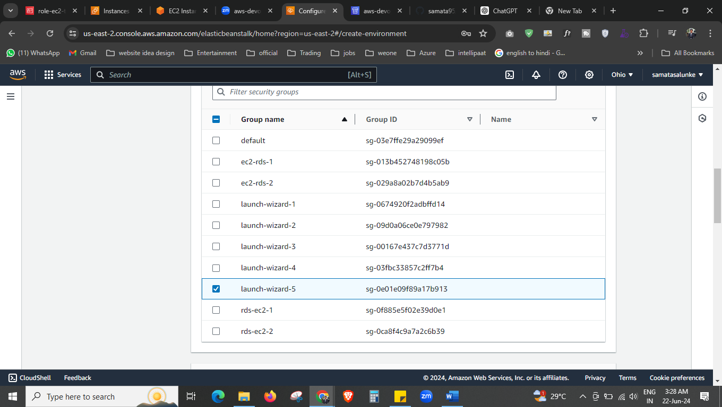

Select your security group.

Next. Next

\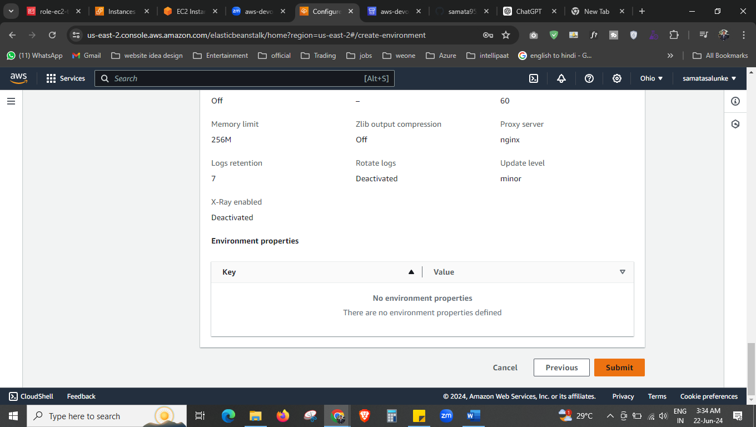

Submit.

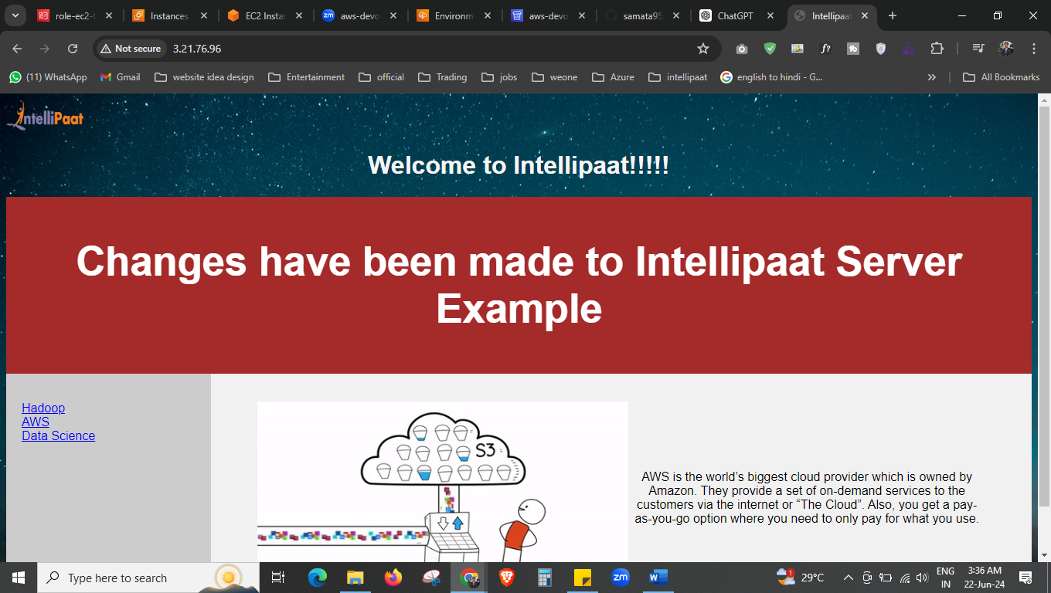

Now if you copy paste public ip of ec2 you can see the output.

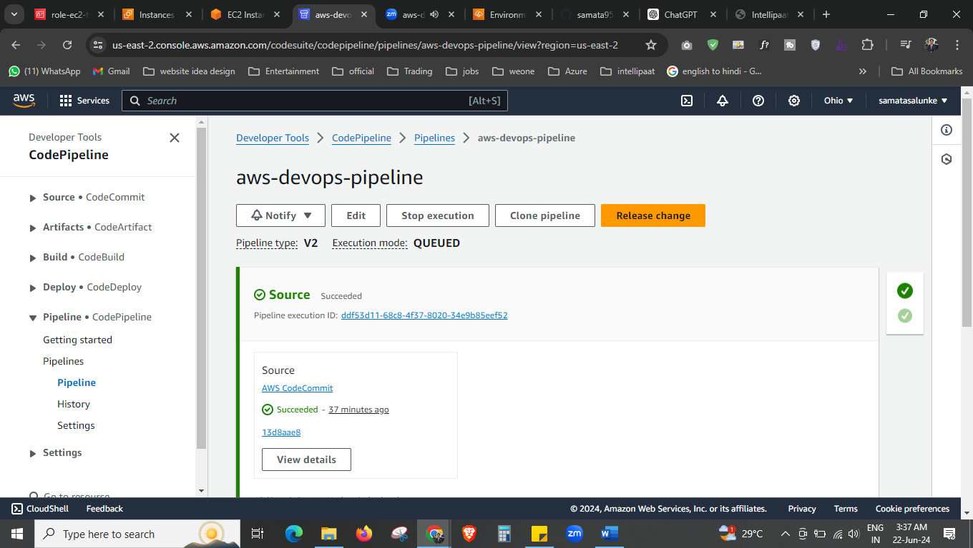

Now go to the pipeline and edit it.

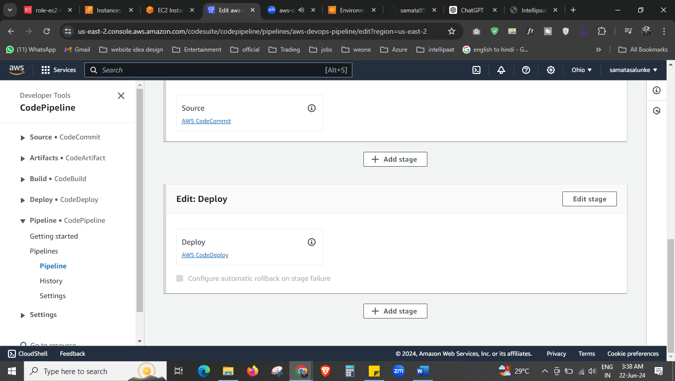



We are editing the deploy stage.

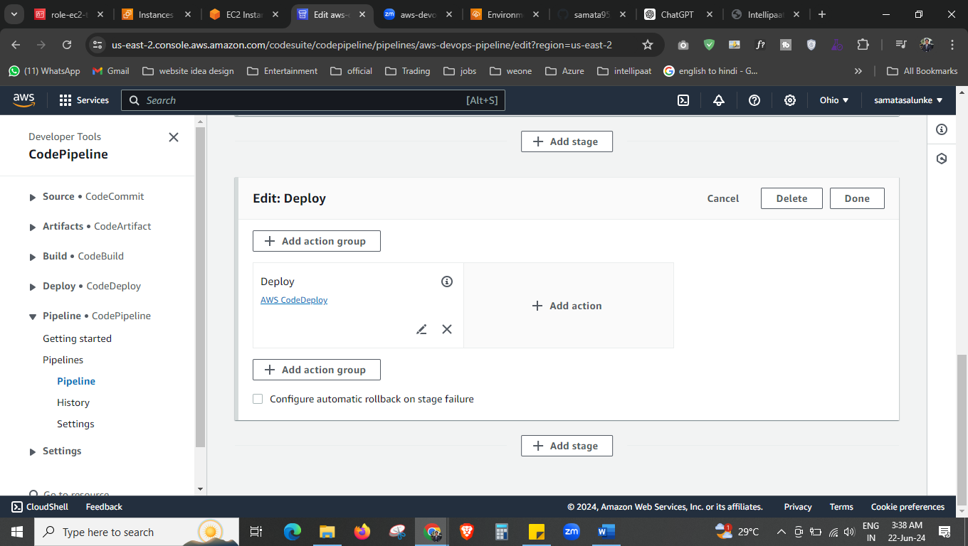



Click here and add action group.

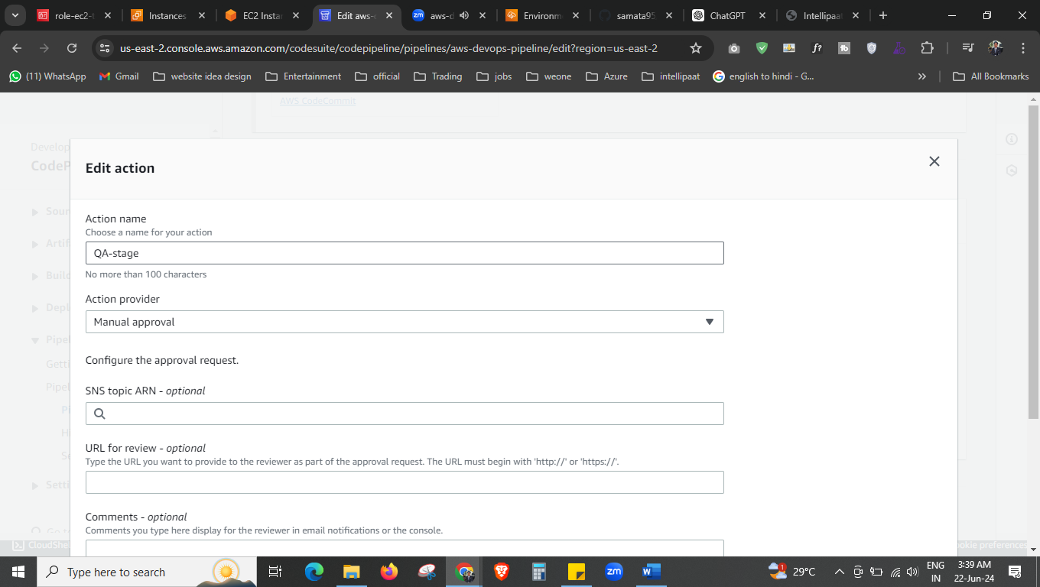

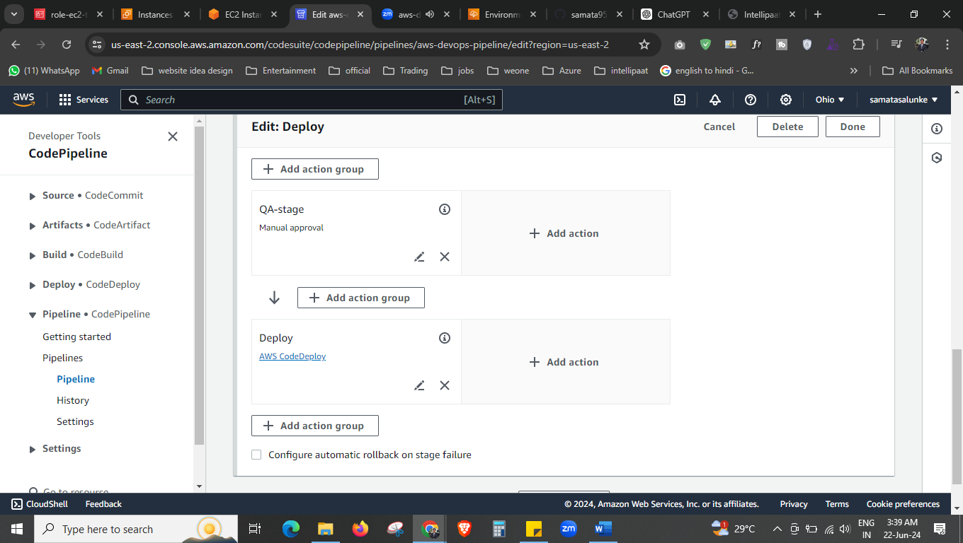

Now you can see we have QA stage also added. Done this and save this.

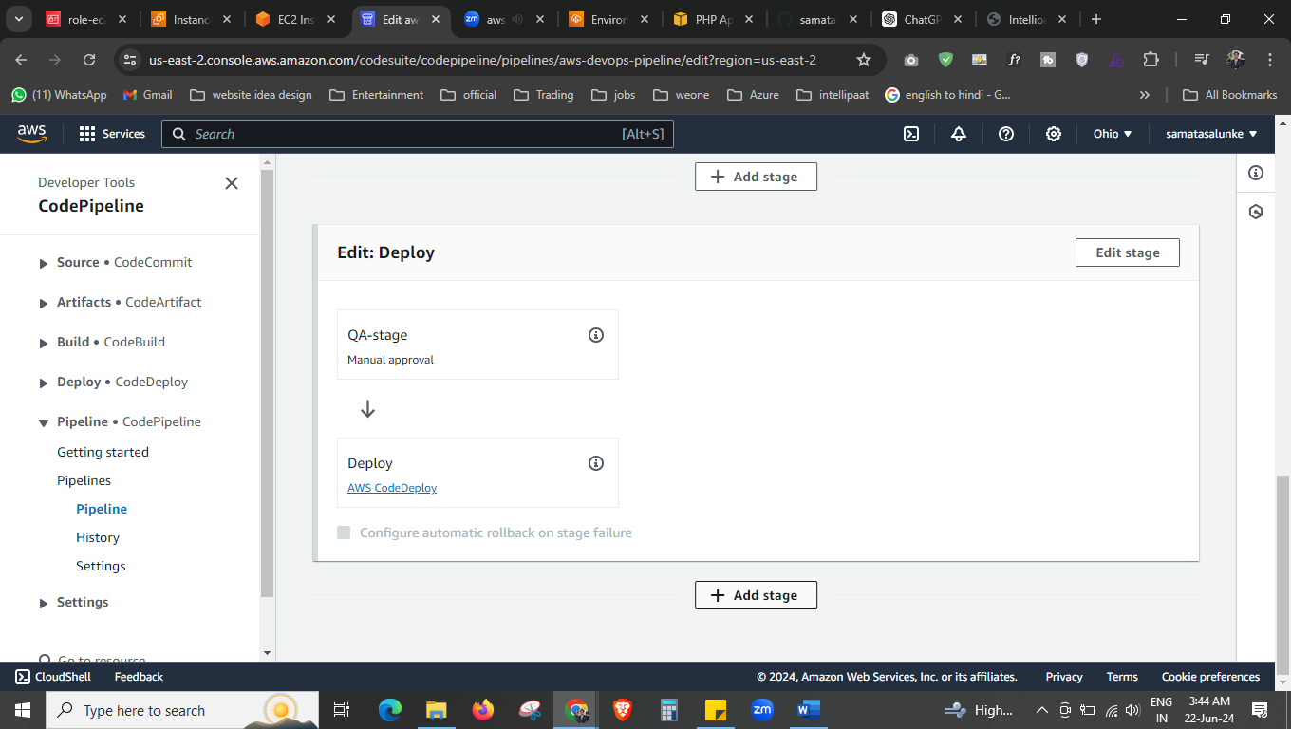

Now again go edit this pipeline, now we are adding one more stage also, that is elastic bean stalk.

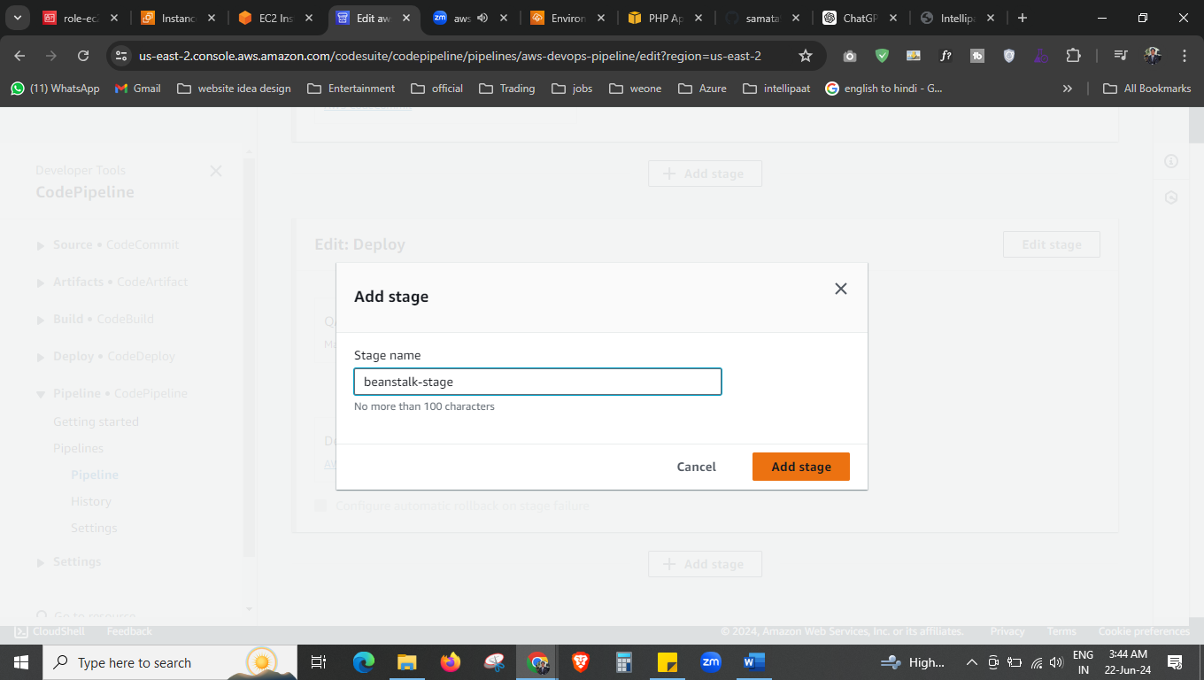

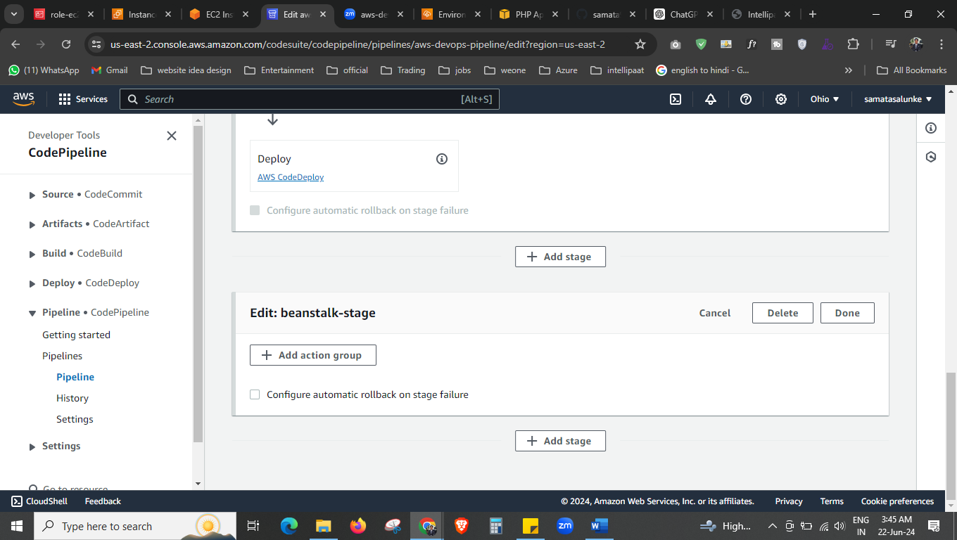



Add the action group.

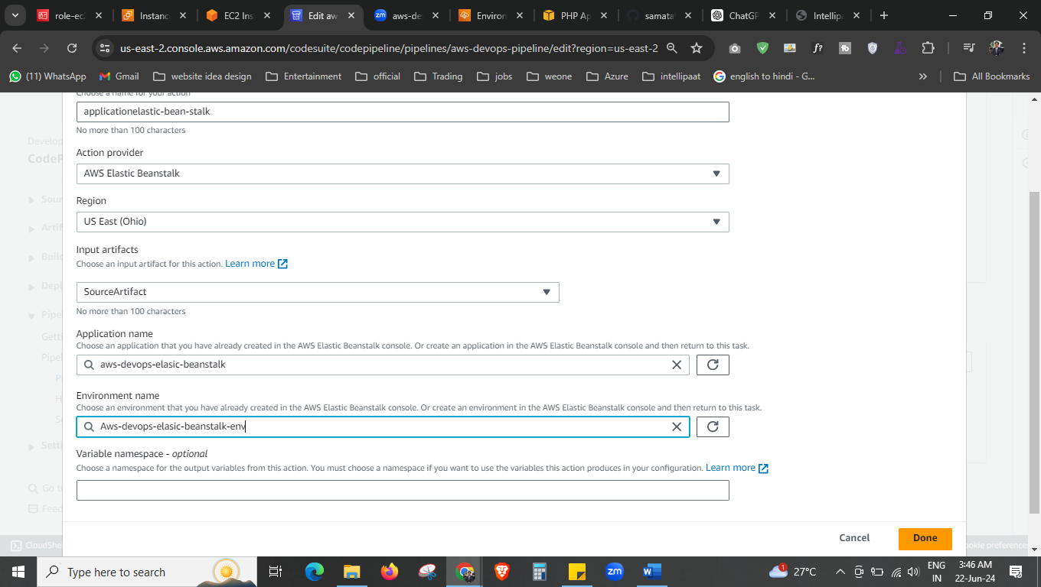



Fill this details. Done

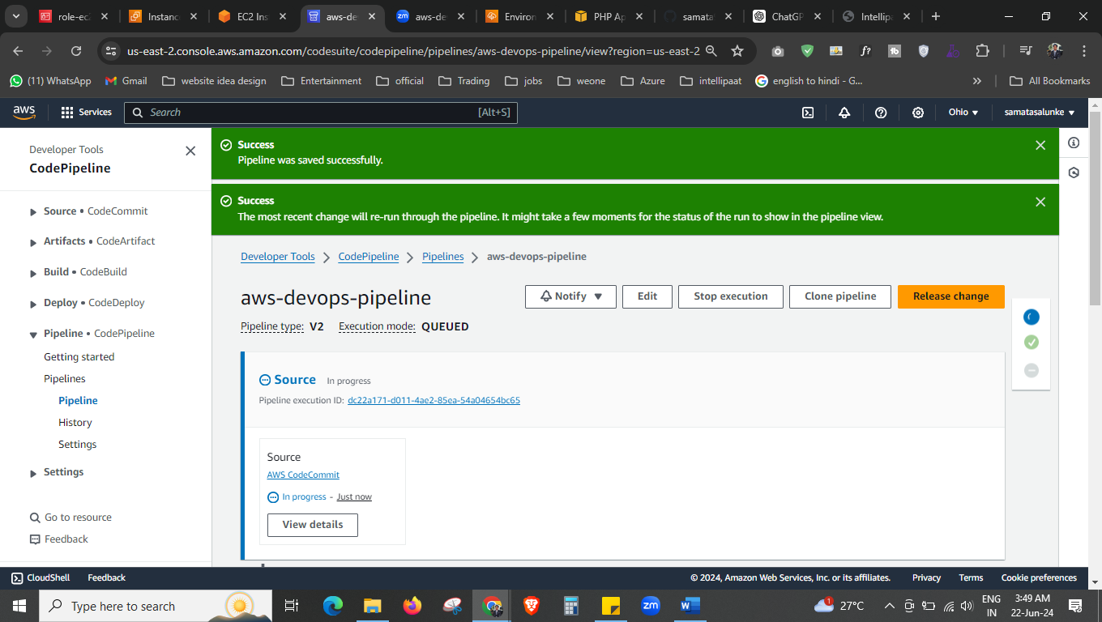now click on relese pipeline.

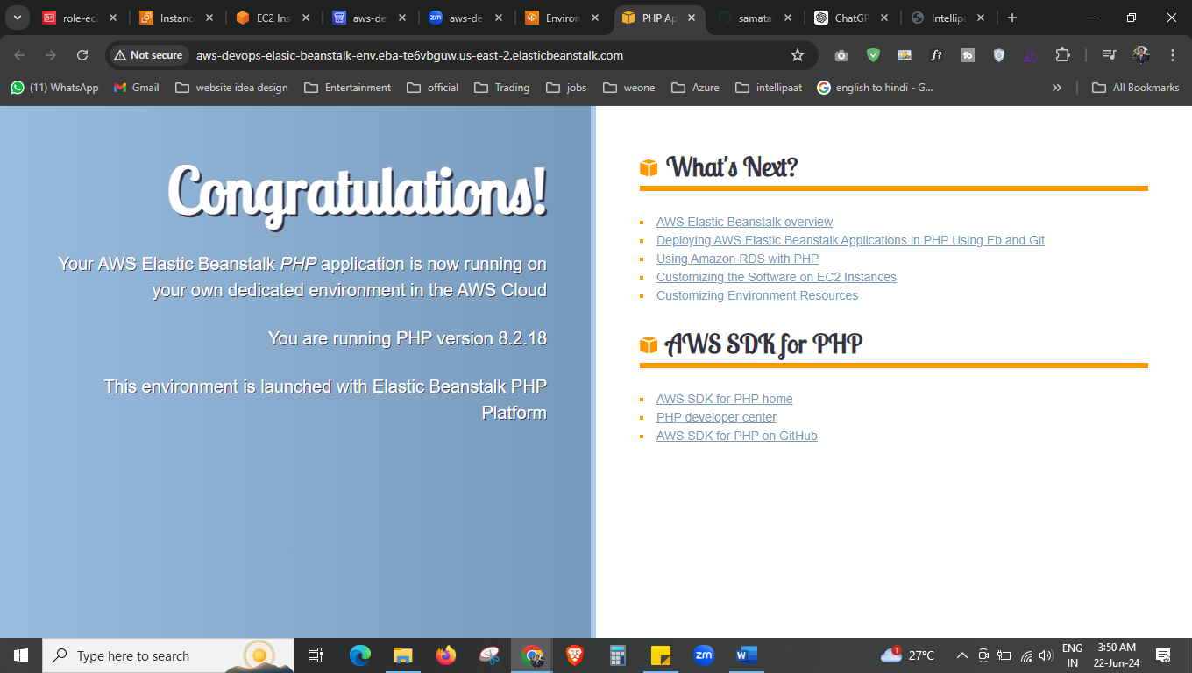

And here our elastic bean stalk is also ready.

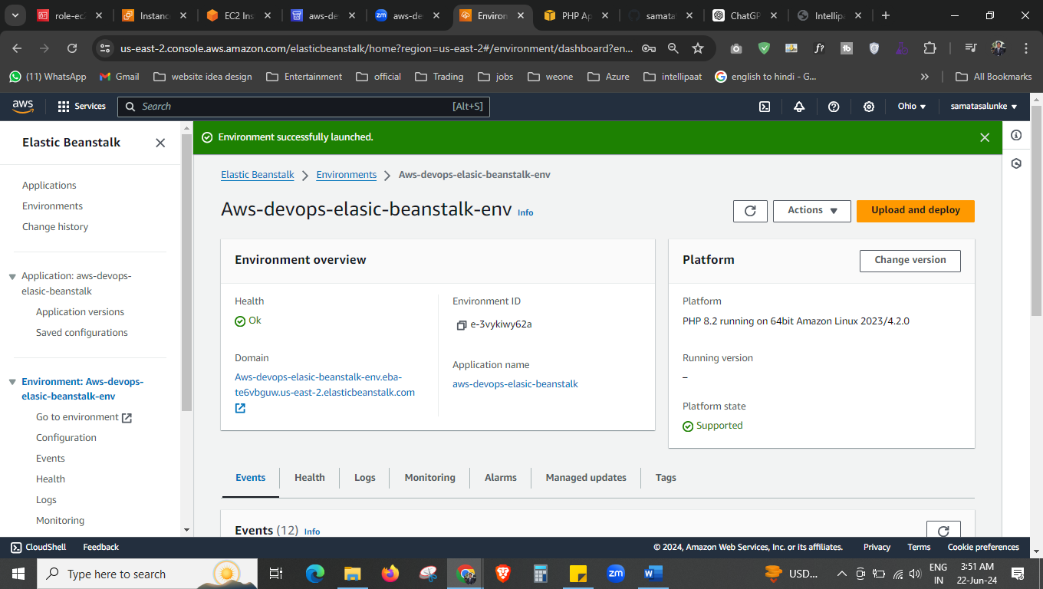



Now go to our elastic bean stalk and upload our code zip. Then again relese pipeline.

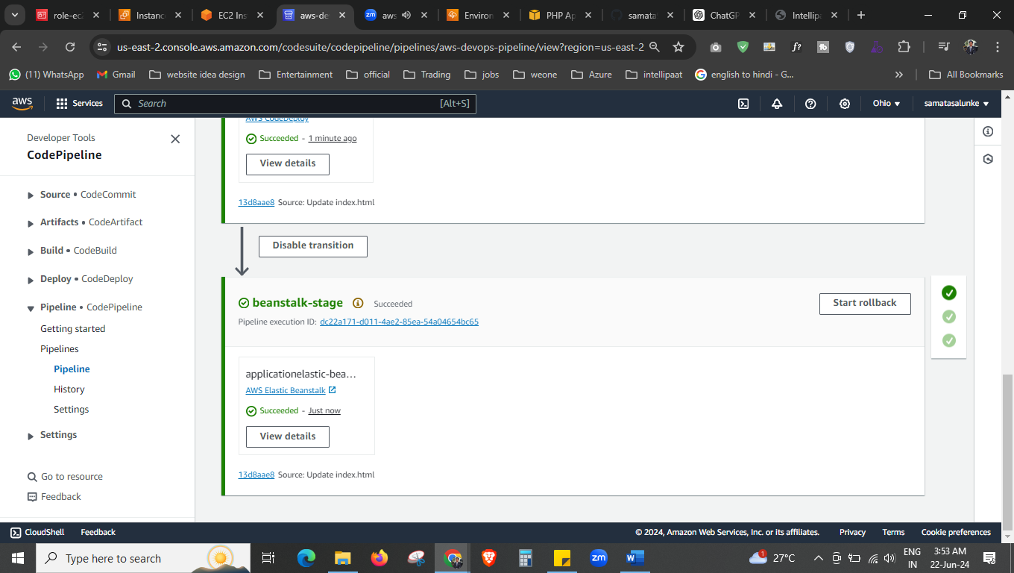

The pipe line is done.

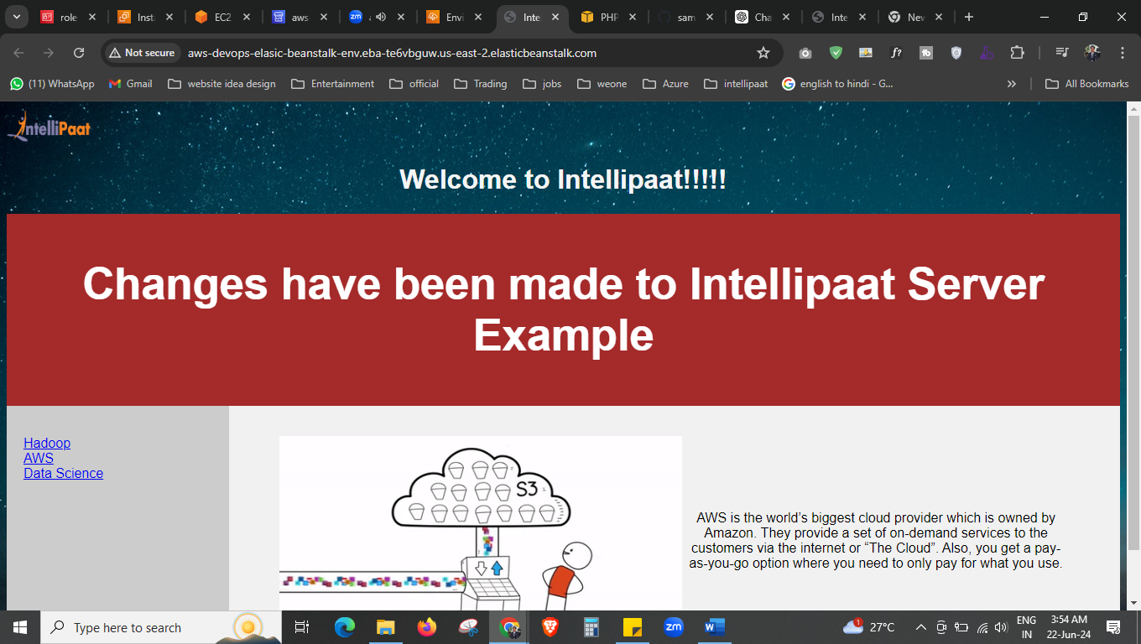

The final output